**CHAPTER 1**

**INTRODUCTION**

###### 

###### **Background**

Agriculture has always been one of most vital pillars of human civilization. It not provides food and raw data’s but offers employment for millions of people around the world. Among all agricultural products, fruits hold a special place because of their rich nutritional value and economic importance. However, fruit cultivation faces a major challenge — the outbreak of various diseases that can seriously affect both the quality and quantity of production.

Fruit diseases are commonly caused by bacteria, viruses, or fungi, and their symptoms usually appear as changes in color, texture, or spots on the surface of fruits and leaves. If these infections are not detected early, they can spread quickly, leading to huge losses for the farmers While this approach can be accurate, it is time-consuming, labor-intensive, and sometimes unreliable due to human error. In rural areas, where expert help may not always be available, farmers often struggle to identify diseases in time, allowing infections to spread further.

With the advancement of technology and the rise of smart farming, there is a growing need for automated systems that can identify diseases quickly and accurately. Artificial Intelligence (AI), Machine Learning (ML), and Deep Learning (DL) have brought significant progress in many fields such as healthcare and security — and are now transforming agriculture as well. One of the most effective deep learning methods is the Convolutional Neural Network (CNN), which excels at image classification and object detection tasks.

CNNs can automatically learn important features like color, shape, and texture from images without requiring manual feature extraction. This makes them highly suitable for fruit disease detections, where even small visual differences can indicate disease symptoms. By training CNN models with large sets of healthy and diseased fruit images, the system can learn to recognize specific patterns and accurately identify different types of diseases.

The project “Fruit Disease Detection using CNN” aims to develop a smart and efficient system that can analyze fruit images and determine whether they are healthy or infected with diseases such as anthracnose or bacterial spot. This system provides quick results, helping farmers take timely action — like applying suitable treatments, improving soil conditions, or removing affected plants — to prevent further spread.

Beyond disease detection, this project also supports the vision of smart and sustainable agriculture. Early and accurate detection reduces the unnecessary use of harmful pesticides, promoting more eco-friendly farming practices.

In conclusion, this project shows how the combination of image processing, and deep learning can tackle one of the biggest challenges in agriculture. By automating fruit disease identification, the system empowers the farmers, enhances productivity.

**1.2 Introduction**

Agriculture is the lifeblood of human civilization, and it's amazing to think about how it continues to shape world. For many people in developing countries, farming isn't just a job - it's a way of life. And when it comes to crops, fruits are like the superheroes of the agricultural world. Not only are they packed with nutrients, but they're also a vital source of income for farmers and a key player in the global economy. But here's the thing: plant diseases are a major threat to fruit production. With bacteria, fungi, and viruses lurking around every corner, it's a constant battle to keep crops healthy and thriving.

Fruit plant diseases can be a real game-changer - or game-ender, depending on how you look at it. They can sneak up at any stage of growth, leaving farmers with lower yields, poor quality fruit, and a dent in their wallet. The signs are often visible, like discoloration or dark spots, but spotting them early is key to stopping the spread. Traditionally, farmers have relied on experts to inspect their crops, but this can be a slow and costly process, especially in rural areas where expertise might be scarce. That's where AI and computer vision come in - a breath of fresh air for the agricultural world. With machine learning and deep learning, we can teach computers to recognize patterns and detect diseases faster and more accurately than ever before. Convolutional Neural Networks (CNNs) are particularly handy for image-based tasks, like spotting those pesky disease symptoms. By automating disease detection, CNNs can give farmers a powerful tool to identify problems early and take action - it's like having a personal plant doctor!The project Imagine having a personal fruit detective that can spot diseases in seconds! "Fruit Disease Detection using CNN" system does just that. By analyzing images of fruits, it can quickly identify disease patterns and tell you exactly what's wrong - or confirm that your fruit is perfectly healthy. The best part? No need to wait for an expert or worry about misdiagnosis. This system uses AI to provide fast, automated, and reliable disease detection, making it a game-changer for farmers, suppliers, and anyone who wants to keep their fruits fresh and healthy.

This approach not only saves time but also enables early detection, preventing large-scale infections and crop losses. It also helps reduce the unnecessary use of pesticides, promoting eco-friendly and sustainable farming. The system can be integrated into web or mobile platforms, allowing farmers to upload fruit images and instantly receive results along with preventive suggestions.

In summary, this project demonstrates how **deep learning, image processing, and AI** can come together to create an innovative solution for one of agriculture’s biggest challenges — fruit disease detection. By automating the detection process, it reduces dependence on manual labor, improves accuracy, and supports the vision of smart and sustainable farming. Ultimately, it benefits farmers, enhances productivity, and contributes to broader goals such as food security and technological advancement in agriculture.

###### 

###### **1.3 Problem Statement**

In agriculture, one of the biggest challenges for farmers and researchers is detecting fruit diseases early and accurately. Fruits are highly vulnerable to infections caused by fungi, bacteria, and viruses, which can greatly reduce both their yield and quality. Disease not only affects the appearance of fruits but also impacts their nutritional value, shelf life, and market price. If infections go unnoticed in the early stages, they can spread quickly, causing widespread crop damage and significant economic losses.

Traditionally, fruit diseases are identified through manual inspection by experienced farmers or agricultural experts. While this method can work for small farms, it has several major drawbacks. It is time-consuming, labor-intensive, and heavily dependent on human expertise. In many rural or developing areas, access to trained professionals is limited, making timely detection difficult. Moreover, manual diagnosis can be prone to errors, especially when disease symptoms are visually similar or appear under varying lighting and environmental conditions.

As fruit cultivation expands and the variety of diseases increases, manual inspection becomes inefficient and unreliable, particularly for large-scale farming. Early-stage infections are often missed, leading to delayed or incorrect treatment. This not only reduces productivity but also results in overuse of pesticides, which harms the environment and increases production costs.

In recent years, advancements in Artificial Intelligence (AI) and Deep Learning (DL) have opened new possibilities for automating agricultural processes and improving precision. Yet, there is still a need for accurate, user-friendly, and real-time systems capable of detecting fruit diseases using image data. Many current solutions rely on traditional image processing methods that require manual feature extraction and often struggle under different lighting conditions, camera qualities, or fruit types.

This highlights the urgent need for a robust, automated, and intelligent system that can identify and classify fruit diseases efficiently, without human intervention. Such a system should be able to analyze fruit images, recognize disease patterns, and provide reliable predictions, helping farmers take timely preventive measures.

The project “Fruit Disease Detection using Convolutional Neural Networks (CNN)” is designed to meet this need. By leveraging deep learning, the system can automatically extract important features from fruit images and classify them into different disease categories. This approach overcomes the limitations of manual diagnosis and traditional machine learning, offering a fasconsistent, and scalable solution for practical agricultural use.

In short, the main goal of this project is to develop an automated, accurate, and efficient fruit disease detection system that helps farmers identify diseases early, reduce losses, improve yield quality, and support sustainable farming practices.

In agriculture, one of the biggest challenges that farmers and researchers face is detecting fruit diseases at an early stage and with high accuracy. Fruits are extremely sensitive to infections caused by fungi, bacteria, and viruses, which can drastically reduce both the quantity and quality of the harvest. The presence of disease doesn’t just spoil the look of the fruits; it can also lower their nutritional value, shorten their shelf life, and reduce their market price. When diseases are not caught early, they can spread rapidly across the crop, causing widespread damage and significant financial losses for farmers.

Traditionally, fruit disease detection relies on manual inspection by experienced farmers or agricultural experts. While this method can work for small-scale farms, it comes with several challenges. It is time-consuming and labor-intensive, and the accuracy of the diagnosis depends heavily on the inspector’s expertise. In many rural or developing regions, farmers have limited access to trained specialists, making timely detection even more difficult. Furthermore, human inspection is prone to errors and subjectivity, especially when disease symptoms are subtle, visually similar, or appear under inconsistent lighting and environmental conditions.

As the cultivation of fruits grows and the number of diseases increases, manual inspection becomes increasingly impractical. Early-stage infections are often missed, which leads to delays in treatment or incorrect application of pesticides. This not only lowers crop productivity but also encourages overuse of chemicals, which can harm the environment and drive up production costs. Clearly, there is a need for a more reliable, efficient, and scalable solution.

Recent advances in Artificial Intelligence (AI) and Deep Learning (DL) have opened new doors for solving this problem. By applying these technologies, it is possible to automate the detection of fruit diseases with precision, speed, and consistency. Despite these advancements, many current solutions still rely on traditional image processing methods. These methods require manual feature extraction and often fail when images are taken in different lighting conditions, with varying camera quality, or across different fruit types.

The reality is, farmers face a tough challenge in detecting fruit diseases quickly and accurately. That's why we need a smart system that can identify diseases just by looking at images of the fruit. Project, "Fruit Disease Detection using CNN", aims to do just that. By harnessing the power of AI, we can help farmers get ahead of diseases, reduce losses, and save time. This system learns from images of fruits, spots patterns, and tells you what's wrong. It's fast, reliable, and scalable - exactly what farmers need to thrive in today's agricultural landscape.

In essence, the primary goal of this project is to develop a system that is automated, accurate, and efficient, enabling farmers to identify diseases early, minimize losses, improve the quality and yield of their harvest, and support sustainable farming practices. By integrating AI with agriculture, this project offers a practical, modern, and technology-driven approach to one of the most pressing challenges in fruit farming today.

**1.4 Motivation**

Agriculture is the foundation of human society, providing sustenance, jobs, and economic security. However, farmers still grapple with a persistent threat: crop diseases, particularly in fruits. These diseases can devastate harvests, diminishing both yield and quality, and dealing a harsh financial blow to farmers who rely on their crops for survival. Often, the symptoms are subtle, allowing the disease to spread rapidly before being detected, leaving farmers to deal with the aftermath of a severely damaged crop.

Farmers typically spot fruit diseases the old-fashioned way - by taking a close look themselves. But this method has its downsides. It relies on individual expertise, can be slow, and often leads to inconsistent results. Plus, in rural areas where specialists are scarce, farmers might not get the help they need when they need it most. This can lead to delayed treatment, reduced yields, and increased costs - a tough pill to swallow for anyone relying on their crops for income.

Technology is revolutionizing agriculture, and AI is leading the charge. Project harnesses the power of Artificial Intelligence and Deep Learning to tackle a major farming challenge: fruit disease detection. By building a smart system that uses image recognition, we're creating a tool that's easy to use, accessible to all, and empowers farmers to catch diseases early. Just snap a photo, upload it, and get instant insights - it's that simple.

The motivation behind this project also comes from a desire to **make farming smarter, more efficient, and more sustainable**. Early and accurate disease detection can help farmers take preventive actions at the right time, reducing the overuse of pesticides and preserving the environment. It also saves time and effort, allowing them to focus more on improving crop quality and yield rather than fighting preventable diseases.

The goal is to bring cutting-edge tech to the heart of agriculture, making it accessible to farmers who need it most. We envision a system that's intuitive, affordable, and empowering - allowing small-scale farmers to tap into the benefits of AI and protect their livelihoods. This project is about more than just innovation; it's about people, communities, and the future of farming. By harnessing technology to drive real-world impact, we aim to make a tangible difference in the lives of farmers, one farm at a time.

**1.5 Scope**

The project “Fruit Disease Detection using CNN” aims to develop an intelligent, automated system capable of detecting and classifying diseases in fruits using images. Leveraging deep learning and computer vision techniques, the system can identify visual symptoms such as color changes, spots, and texture variations to accurately determine the type of disease affecting the fruit.

This system is designed to support farmers, agricultural experts, and researchers by providing early and accurate disease detection, reducing reliance on manual inspections and expert knowledge. Early identification of diseases helps prevent their spread, minimizes crop losses, and reduces the overuse of chemical pesticides, promoting eco-friendly and sustainable farming practices.

###### Imagine having a personal crop advisor in your pocket. Project brings this vision to life, allowing farmers to upload images of their fruits and get instant insights on disease detection and prevention. As the system grows, it can be expanded to cover more fruit types and diseases, becoming even more accurate and efficient. By fusing AI with agriculture, we're not just boosting productivity - we're paving the way for a smarter, more sustainable farming future that benefits everyone.

**CHAPTER 2**

**LITERATURE REVIEW**

**2.1 Multiple Fruit Disease Detection Using Deep Learning[Varadraj Jadhav, Harshal Giri, Harish Thore, Kshitij Patil, Hemant Pawar, Dr. Tushar** **Phadtare(2024)]**

The paper *“Mutiple Fruit Disease Detection Using CNN and Multi-Spectral Imaging Techniques”* "This research presents a cutting-edge computer vision system that pairs multi-spectral imaging with Convolutional Neural Networks (CNNs) to accurately identify external fruit defects and diseases. By leveraging Near-Infrared (NIR) imaging and deep learning, the system overcomes the limitations of manual inspections, which are often slow, inconsistent, and prone to errors. The innovative approach enables precise and reliable disease detection, facilitating early intervention and informed crop management in precision agriculture."

The system follows a structured methodology involving segmentation, image preprocessing, feature extraction, and classification. Initially, fruit regions are segmented from NIR images, and both Red (NIR) and RGB composite images are created. Adaptive preprocessing is then applied to improve contrast and eliminate noise. A thresholding mechanism across seven colour components identifies defective regions, and a voting process determines the final classification of the fruit as healthy or diseased. The CNN model is trained using a large dataset of healthy and infected fruit images, allowing it to learn distinct visual features such as color changes, texture variations, and surface patterns. Experimental evaluation confirms that the model achieves high accuracy and robustness, demonstrating its practical value for automated agricultural disease monitoring.

Key Aspects:

Depp Learning Model s: The study employs Convolutional Neural Networks (CNNs), a deep learning architecture well-suited for image recognition tasks. CNNs automatically extract relevant spatialfeatures,.

Multi-Spectral Image Analysis:The system integrates Near-Infrared (NIR) and RGB imaging to capture detailed spectral and color information from fruit surfaces. This multimodal approach enhances the ability to identify subtle or early-stage disease symptoms that are not visible in standard RGB images.

Automated Disease Detection:The proposed method automates the entire process of fruit disease identification — from image acquisition to classification — reducing the need for human expertise and ensuring consistent detection performance in large-scale agricultural environments.

Robust Preprocessing and Thresholding:Adaptive preprocessing techniques and threshold-based segmentation across seven color components ensure accurate defect localization. The use of a voting mechanism improves reliability by combining multiple spectral cues for final decision-making.  
The experimental results show that the system performs effectively across different fruit types and disease categories. Its scalability allows integration into IoT-based smart farming and mobile applications, promoting real-time disease monitoring and early intervention in the field.

**2.2 Guava Disease Detection Using Deep Convolutional Neural Networks [R. S. Prasad, K. S (2023)]**

"A revolutionary AI-powered system is transforming guava disease detection, enabling farmers and experts to identify 26 different leaf diseases with remarkable accuracy. By harnessing the power of Deep Convolutional Neural Networks (CNNs) and a vast dataset of guava leaf images, this innovation achieves an impressive 99.35% accuracy rate. With its robust performance, real-time capabilities, and mobile accessibility, this system empowers farmers to detect diseases early, plan effective treatments, and take timely action. This breakthrough has the potential to redefine smart farming and precision agriculture, paving the way for a more sustainable future."

Key Aspects:

Deep Learning Techniques: The study employs Deep Convolutional Neural Networks (CNNs) to automatically learn discriminative features from guava leaf images, eliminating the need for manual feature extraction. The model captures intricate visual patterns like color shifts, lesion textures, and vein distortions, which are vital indicators of disease.

Extensive Dataset and Augmentation: The researchers used a large dataset containing thousands of guava leaf images across 26 disease classes. Data augmentation techniques such as rotation, scaling, and flipping were applied to increase dataset diversity and prevent overfitting, leading to better model generalization.

Automated Disease Identification: The system autonomously detects and classifies guava diseases, providing fast and accurate results. This automation simplifies the diagnostic process, especially in remote agricultural areas where expert guidance may be limited.

High Accuracy and Performance: With an overall accuracy of 99.35%, the model outperforms traditional machine learning methods. The inclusion of preprocessing techniques such as noise removal and normalization significantly improved detection reliability.

Field Implementation Potential: The study emphasizes deploying the CNN model on mobile and web-based agricultural advisory systems, making disease detection accessible to farmers in real-time. This supports timely decision-making and reduces crop losses through early disease management.

**2.3 CNN and SVM-Based Model for Watermelon Disease Classification [P. Kumar, S. R. Gupta. (2022)]**

“This is being able to spot watermelon diseases early on, saving crops and ensuring better yields. This research takes a significant step towards making that a reality. By combining the powers of Convolutional Neural Networks (CNNs) and Support Vector Machines (SVMs), the team developed a hybrid model that can accurately detect and classify watermelon leaf diseases. This innovative approach leverages CNNs to extract key features from images and SVMs to classify them, resulting in a robust and reliable system. With an accuracy of 88.13%, this model outperforms traditional methods and has the potential to revolutionize disease detection in watermelon crops.”

Key Aspects:

Hybrid Deep Learning Approach: The study integrates CNN and SVM, where CNNs extract high-level spatial features from images and SVMs classify those features effectively. This combination enhances the model’s precision and reduces overfitting, especially on small or imbalanced datasets.

Robust Feature Extraction: CNN layers automatically capture intricate features such as disease spots, leaf discoloration, and texture variations, providing a robust representation for the classification process.

Improved Accuracy and Efficiency: The proposed CNN-SVM hybrid model achieved 88.13% accuracy, significantly outperforming conventional ML models like RF and k-NN. The hybridization helps in achieving faster convergence and more reliable predictions.

Comparative Evaluation: The researchers conducted extensive comparisons between the hybrid model and traditional approaches. The CNN-SVM model demonstrated superior accuracy, precision, and recall, validating its effectiveness in plant disease detection tasks.

Practical Implications: The paper highlights the model’s potential for real-world agricultural use, where early detection of watermelon diseases can prevent large-scale crop losses. The authors also suggest integrating the system into mobile or IoT-based platforms for real-time disease diagnosis and farmer assistance.

Practical Application in Smart Farming: The authors propose integrating the model into smartphone-based and IoT-enabled agricultural platforms, allowing farmers to capture and analyze leaf images in real time. This supports early intervention, precision treatment, and sustainable farming practices.

**2.4 Optimized Deep Learning Framework for Pomegranate Disease Detection [R. K. Sharma (2021)]**

"Pomegranate farming just got a whole lot smarter! This research introduces a cutting-edge deep learning framework that helps farmers detect and classify pomegranate diseases quickly and accurately. By fine-tuning the model to optimize speed and accuracy, the team created a powerful tool that can help farmers identify issues early, reduce crop loss, and make informed decisions. It's a game-changer for farmers who want to protect their livelihoods and produce high-quality pomegranates."

The study focuses on detecting several common diseases such as bacterial blight, fruit rot, and leaf spot, which are known to severely affect pomegranate cultivation. The dataset used for training and testing was curated from real-field conditions, ensuring the model’s robustness under diverse lighting and environmental variations. The optimization process involved techniques such as hyperparameter tuning, dropout regularization, and transfer learning, leading to superior model generalization. The proposed framework achieved high performance with an accuracy exceeding 97%, demonstrating its effectiveness compared to conventional CNN models.

Key Aspects:

Optimized Deep Learning Model: The framework employs an enhanced CNN architecture with optimized hyperparameters like learning rate, filter size, and batch normalization. This optimization reduces training time and improves classification performance.

Transfer Learning Integration: Pre-trained models such as VGG16 and ResNet50 were fine-tuned for pomegranate disease data, enabling the system to leverage existing visual knowledge while adapting to new agricultural contexts.

Robust Image Preprocessing: The study includes preprocessing techniques such as noise filtering, color normalization, and background removal to enhance image clarity and highlight diseased regions more effectively.

High Accuracy and Reliability: With an accuracy rate above 97%, the optimized framework outperformed standard CNN and other machine learning methods. The inclusion of dropout layers and batch normalization improved stability and prevented overfitting.

Practical Application in Smart Farming: The authors propose integrating the model into smartphone-based and IoT-enabled agricultural platforms, allowing farmers to capture and analyze leaf images in real time. This supports early intervention, precision treatment, and sustainable farming practices.

**2.5** **Fruit Disease Detection Using Deep Convolutional Neural Networks [Gupta R., Sharma A (2020)]**

"Imagine being able to detect fruit diseases at a glance, without needing an expert. This research makes that possible with a powerful deep learning model that uses Convolutional Neural Networks (CNNs) to identify and classify fruit diseases. By analyzing images of various fruits like apples, bananas, grapes, and mangoes, the model can spot issues like apple scab, black rot, and citrus canker with impressive accuracy. This tech has the potential to revolutionize the way we approach fruit disease detection, making it faster, more efficient, and accessible to all."

The framework is designed to assist farmers and agricultural experts by providing a fast, reliable, and automated system for disease diagnosis, ultimately supporting early intervention and preventing crop losses. Additionally, the paper highlights the model’s adaptability for mobile and web-based platforms, ensuring accessibility for real-time field usage. The integration of deep learning with precision agriculture represents a significant step toward intelligent and sustainable farming systems.

Key Aspects:

Deep Learning Techniques: The study employs Convolutional Neural Networks (CNNs) to learn spatial hierarchies of features from raw fruit images. The network automatically captures complex visual cues such as color variation, texture irregularities, and shape deformities that are indicative of specific fruit diseases.

Image-Based Disease Detection: The research focuses on analyzing digital images of fruits under varied environmental conditions. By using preprocessing techniques such as image resizing, normalization, and augmentation, the model achieves improved robustness and accuracy.

Automated Classification System: The proposed CNN framework is capable of automatically classifying fruit images into healthy and diseased categories without manual intervention. This automation reduces human dependency and minimizes diagnostic time in large-scale agricultural setups.

High Accuracy and Scalability: The model achieves an average accuracy of 98–99% across multiple fruit types. Its scalable architecture allows for the inclusion of additional fruit datasets and disease categories, making it applicable to diverse agricultural scenarios.

Real-Time Implementation: The study discusses the feasibility of implementing the CNN model on edge devices and mobile platforms, enabling farmers to detect diseases in real time using smartphone cameras. This promotes digital transformation in agriculture by making intelligent solutions accessible to all.

**2.6** **A CNN Model for Early Detection of Pepper Phytophthora Blight [Z. Duan, H. Li, C. Li, et al. (2021)]**

The paper “A CNN Model for Early Detection of Pepper Phytophthora Blight Using Multispectral Imaging” presents an advanced deep learning framework that integrates spectral and textural data for accurate detection of *Phytophthora blight* in pepper plants. This research emphasizes the importance of identifying diseases at an early stage to prevent yield losses. By employing multispectral cameras in combination with Convolutional Neural Networks (CNNs), the system captures detailed surface and internal characteristics of leaves. The study overcomes the limitations of traditional RGB-based detection methods by introducing high-dimensional spectral analysis.

The methodology involves image acquisition using multispectral sensors, preprocessing through normalization and noise filtering, followed by feature extraction that integrates both spectral reflectance and spatial texture. The CNN model is trained to classify healthy and infected plants based on the fused data, achieving superior accuracy compared to conventional approaches. Experimental results demonstrated that the proposed model not only identifies early-stage infections but also distinguishes between various disease severity levels.

Key Aspects:

* Spectral–Textural Fusion: Combines spectral imaging and CNN-based texture analysis for improved accuracy.
* Early Detection: Focuses on detecting early-stage symptoms invisible to human eyes.
* Deep Learning Architecture: Employs CNNs to automatically learn discriminative features.
* Agricultural Application**:** Supports precision farming through smart disease diagnosis.

The paper concludes that integrating deep learning with multispectral imaging significantly enhances the reliability of fruit and vegetable disease detection systems and enables scalable agricultural monitoring solutions.

**2.7 A High-Precision Detection Method of Apple Leaf Diseases Using Improved Faster**

**[X. Gong, S. Zhang (2022)]**

"Detecting apple leaf diseases just got a whole lot easier! Researchers have developed a powerful new method that uses an improved Faster R-CNN model to spot diseases like rust, scab, and black rot with high precision. By enhancing the model's ability to extract key features and handle tricky conditions like complex backgrounds and changing light, this approach tackles real-world challenges head-on. The result? More accurate disease detection that can help farmers protect their crops and improve yields."The system’s pipeline includes image collection, preprocessing (contrast normalization and resizing), and region proposal generation using the improved R-CNN architecture. The integration of multi-scale feature extraction layers enables the model to accurately locate small and overlapping lesions. The model was trained on a comprehensive dataset of labeled apple leaf images, achieving an overall accuracy of over 98%. The results proved its robustness in detecting diseases with minimal false positives.

Key Aspects:

* Improved R-CNN Architecture: Enhances accuracy by combining ResNet and FPN.
* Multi-Disease Classification: Detects multiple apple diseases with high precision.
* Real-World Robustness: Handles environmental variations and complex image backgrounds.
* High Accuracy: Demonstrates 98% accuracy, making it reliable for field use.

The paper highlights that integrating advanced CNN architectures with region-based detection methods can revolutionize fruit disease monitoring systems, providing real-time insights for smart agricultural management.

**2.8 A Precise Fruit Disease Identification Model Based on Context Data Fusion**

**[PFDI Research Group (2022)**

The paper “PFDI: A Precise Fruit Disease Identification Model Based on Context Data Fusion with Faster-CNN in Edge Computing Environment” introduces an innovative system for real-time fruit disease detection, optimized for edge devices such as drones and smartphones. The model combines context-aware data fusion (including temperature, humidity, and soil conditions) with Faster-CNN architecture, allowing it to process environmental and visual data simultaneously. This hybrid approach improves diagnostic accuracy and ensures adaptability across different climatic conditions.

The study follows a structured process beginning with multimodal data acquisition from sensors and cameras. The preprocessing stage involves normalization, feature extraction, and context integration, followed by CNN-based classification. The edge-deployable design ensures the system operates efficiently with limited computational resources while maintaining high accuracy (above 97%).

Key Aspects:

* Contextual Data Fusion: Integrates visual and environmental parameters for precise diagnosis.
* Edge Computing Deployment: Enables real-time detection on low-power devices.
* Faster-CNN Backbone: Enhances feature learning and detection efficiency.
* Scalability and Flexibility: Adaptable to different fruit types and growing environments.

This work represents a major step forward in smart agricultural IoT systems, offering an efficient and scalable model for on-site fruit disease monitoring without relying heavily on cloud infrastructure.

**2.9** **Comparative Analysis of CNN, EfficientNet and ResNet for Grape Disease Prediction: A Deep Learning Approach[S.V.Sinha & B.M.Patil(2024)]**

The paper “Comparative Analysis of CNN, EfficientNet and ResNet for Grape Disease Prediction: A Deep Learning Approach” compares the performance of several modern deep CNN architectures (standard CNN, ResNet, EfficientNet) on grape leaf disease classification, showing which architectures perform better under different disease types and image quality conditions. It applies data augmentation and standardized preprocessing across these models and finds that EfficientNet (or one of the architectures tested) provides a favorable trade-off between accuracy and computational efficiency under realistic conditions.  
**Key Aspects:**

* Tests multiple architectures for grape disease detection: CNN baseline, ResNet, and

EfficientNet.

* Uses standardized preprocessing and data augmentation to fairly compare models.
* Evaluates accuracy, precision etc., showing which architecture is best under constrained scenarios.
* Helps inform architecture choice when balancing performance vs. complexity.

**2.10** **Detection and Classification of Diseases in Multi-Crop Leaves using LSTM and CNN**

**[Srinivas Kanakala, Sneha Ningappa (2021)]**

"Imagine being able to detect diseases in various crops with high accuracy, using a single powerful system. Researchers have made this a reality by combining the strengths of Convolutional Neural Networks (CNNs) and Long Short-Term Memory (LSTM) networks. This innovative approach leverages CNNs to extract key features from leaf images and LSTMs to analyze sequential patterns, resulting in impressive training and validation accuracies of 99.1% and 96.4% respectively. This breakthrough can help farmers and agricultural experts identify diseases across multiple crops, enabling early intervention and better harvests."

**Key Aspects:**

* Uses a large, multi-crop dataset (70,295 training images + 17,572 validation) covering **38 disease classes**.
* CNN extracts visual features; LSTM captures sequence or pattern dynamics (if images are viewed in series or along related feature sets) to improve classification.
* Performance evaluated with precision, recall, F1-score, and confusion matrix, showing the CNN + LSTM combo was more robust than using CNN alone.

**CHAPTER 3**

**PROPOSED SYSTEM**

"The goal is to create a smart and user-friendly system that helps farmers detect fruit diseases quickly and accurately. Using advanced image analysis and deep learning, we've developed a system that can identify disease patterns in fruit images. This means farmers can upload a photo of their fruit and get instant insights on whether it's healthy or not. If a disease is detected, system provides personalized advice on how to treat it. By automating this process, we're aiming to reduce the reliance on manual inspections, which can be time-consuming and prone to errors."

"The journey starts with capturing images of various fruits like guava, pomegranate, mango, and watermelon in different lighting and environmental conditions. We then refine these images through preprocessing, which involves resizing, noise reduction, and normalization. To make model more resilient, we also apply techniques like rotation, flipping, and scaling. With images ready, we split them into training and testing sets, setting the stage for effective model training and evaluation."

"At the core of system lies a powerful CNN architecture, comprising multiple layers that collaborate to extract insights from fruit images. Convolutional layers identify crucial visual cues like color anomalies, texture irregularities, and shape distortions that often signal disease. Pooling layers then distill these features, retaining the essentials while streamlining computation. The output is then channeled through dense layers for classification, culminating in a softmax layer that assigns probabilities to each class, effectively determining whether the fruit is healthy or affected by a specific disease."To enhance accuracy and generalization, the system employs data augmentation and dropout layers to prevent overfitting during training. The CNN is trained using labeled datasets from reliable agricultural sources and open repositories like Kaggle and PlantVillage. Model training involves optimizing parameters with backpropagation and the Adam optimizer to minimize loss. Once trained, the model can provide real-time predictions when new images are uploaded.

The user interface, developed using Streamlit, allows easy interaction. Users can upload images, view disease classification results along with prediction confidence, and access brief descriptions and preventive suggestions for the detected disease. A history management feature stores previously analyzed results, enabling users to monitor trends and review earlier reports conveniently.

"The system leverages Python's powerful ecosystem, combining TensorFlow, Keras, OpenCV, NumPy, and Matplotlib to build a high-performance fruit disease detection model. By learning intricate patterns in fruit images, CNN model achieves superior accuracy, surpassing traditional machine learning approaches that rely on manual feature engineering. With its flexible architecture, framework can seamlessly integrate more fruits and crops, paving the way for widespread adoption in precision agriculture.By merging AI and computer vision, this innovative system revolutionizes farming through early disease detection, precise interventions, and automation. It reduces reliance on specialized expertise, cuts costs, and accelerates diagnosis with remarkable accuracy. The outcome is a more sustainable farming model that minimizes losses, promotes healthier yields, and enhances food security, ultimately leading to better-quality produce."At its heart lies the power of Convolutional Neural Networks (CNNs), a type of deep learning model capable of analyzing images and identifying complex patterns that indicate disease. This system was developed to tackle the challenges of traditional fruit inspection, which relies heavily on manual observation. Manual methods are not only time-consuming and labor-intensive but are also prone to errors and require expert knowledge—resources that are often limited, especially for small-scale or rural farmers.

With this system, farmers or users can simply upload an image of a fruit through an easy-to-use web interface. The system then automatically analyzes the image to determine whether the fruit is healthy or affected by a disease. In cases where a disease is present, the system goes further by identifying the specific type of disease and offering practical preventive measures or treatment suggestions. This helps farmers take timely action, potentially saving entire harvests from infection.

"To build a robust fruit disease detection system, we start by collecting a diverse set of images of various fruits like guavas, pomegranates, mangoes, and watermelons, captured in different lighting conditions and environments. We then fine-tune these images through preprocessing techniques like resizing, noise reduction, and normalization to ensure they're model-ready. To make model more resilient, we also apply data augmentation techniques like rotation, flipping, and brightness adjustments. This helps system perform well even with new, unseen data. "To train model, we divided the dataset into training and testing sets, ensuring it learns effectively and produces reliable outcomes. At the heart of system is a CNN architecture that leverages multiple layers to analyze fruit images and detect disease symptoms like discoloration, lesions, or shape irregularities. Through a combination of convolutional, pooling, and dense layers, model accurately classifies fruits as healthy or infected, with the final layer providing probability-based diagnoses."

To further improve accuracy and generalization, the system incorporates techniques like dropout and data augmentation, which help prevent overfitting and ensure the model performs reliably across diverse conditions. The CNN is trained using labeled datasets obtained from reliable agricultural sources, including open repositories like Kaggle and PlantVillage. During training, parameters are optimized using backpropagation and the Adam optimizer, which minimizes the error and ensures the network learns effectively. Once trained, the system can provide real-time predictions for newly uploaded fruit images.

The user interface, developed using Streamlit, is designed for simplicity and accessibility. Users can upload fruit images, view classification results along with the model’s confidence level, and receive brief descriptions and preventive measures for the detected disease. The interface also includes a history management feature, which stores past results, allowing users to track trends, compare past predictions, and monitor disease progression over time.

The system is implemented in Python, leveraging powerful libraries such as TensorFlow, Keras, OpenCV, NumPy, and Matplotlib. By automatically learning deep spatial features from images, the CNN achieves high accuracy and outperforms traditional machine learning methods like SVMs or random forests, which rely heavily on manually crafted features. The framework is scalable and adaptable, capable of detecting diseases in additional fruits and crops as new data becomes available, making it a versatile tool for precision agriculture.

By integrating artificial intelligence and computer vision into agriculture, this system promotes smart farming practices. Early detection of diseases enables farmers to act promptly, reducing crop loss, improving fruit quality, and enhancing overall productivity. Automation also lowers the dependency on agricultural experts, minimizes costs, and accelerates the disease diagnosis process. Ultimately, the system supports sustainable farming practices by reducing unnecessary pesticide usage and contributing to healthier fruit production, better yields, and stronger food security for communities reliant on agriculture

**CHAPTER 4**

**METHODOLOGY**

The methodology for the **Fruit Disease Detection project using CNN** is designed to provide a practical and intelligent solution for one of the biggest challenges farmers face: identifying and managing fruit diseases efficiently. At its heart, the system combines **deep learning, image processing, and real-time predictions** to make disease detection faster, more accurate, and accessible to everyone.

The journey begins with **collecting images of fruits**, both healthy and diseased. These images come from a variety of sources—online datasets, local farms, agricultural research centers, and markets. They capture fruits in different stages of growth, under various lighting conditions, from multiple angles, and with diverse types of diseases. Each image is carefully labeled to mark the disease or indicate that the fruit is healthy. This step is crucial because a well-prepared, high-quality dataset is the backbone of an effective deep learning model. Ethical practices, like getting permission for farm images, are strictly followed to ensure responsible data collection.

Once the images are collected, they undergo **preprocessing** to make them consistent and ready for the CNN. "The preprocessing pipeline includes resizing images to a uniform dimension, normalizing pixel values for efficient learning, and minimizing noise that could impact feature detection. To enhance the system's robustness, we apply data augmentation techniques like rotation, flipping, zooming, brightness adjustment, and cropping. This enables the model to accurately analyze images captured in diverse real-world conditions, including varied angles, lighting setups, and minor damage.Next, CNN model extracts crucial features from the images, automatically identifying visual patterns that indicate disease. Convolutional layers pinpoint subtle signs like discoloration, lesions, and texture irregularities, while pooling layers distill the data, retaining key features and promoting efficiency. The features are then analyzed by fully connected layers, which integrate both fine details and broader patterns, enabling the network to distinguish between healthy and diseased fruits. This approach eliminates the need for manual feature definition, a process that's often tedious and prone to errors." “Once the model has learned these patterns, it moves to the **classification phase**. Here, the CNN determines whether a fruit is healthy or infected and, if infected, identifies the specific disease. The network uses multiple layers with  **activation functions** to capture intricate patterns in the data. Techniques like dropout, batch normalization, and early stopping are applied to prevent overfitting, while the **Adam optimizer** helps the model converge quickly and efficiently. Metrics like accuracy, precision, recall, and F1-score are used to track the model’s performance during training. Once trained, the model can perform **real-time predictions**, allowing farmers or agricultural experts to upload images and get instant feedback along with a confidence score. This quick diagnosis can make a huge difference in preventing the spread of disease and reducing crop losses.”

But the system doesn’t stop at detection. It also provides **actionable recommendations**. After identifying a disease, the system suggests practical measures—like which pesticides to use, nutrient supplements, pruning techniques, or changes in cultivation practices—to help farmers manage the problem effectively. Visual feedback highlights the affected regions on the fruit, helping users see exactly where the disease is and understand its severity.

Finally, the methodology emphasizes **scalability and continuous improvement**. New fruits, diseases, and image variations can be added over time, and cloud-based deployment ensures that multiple users can access the system simultaneously without performance issues. Continuous retraining with new images and user feedback ensures the model stays accurate and adapts to new challenges or emerging diseases.

In essence, this methodology is designed to **empower farmers with a reliable, fast, and practical tool**. By combining careful data collection, preprocessing, automatic feature extraction, CNN-based classification, real-time prediction, and actionable guidance, the system helps farmers detect diseases early, take timely action, reduce crop losses, improve productivity, and promote sustainable farming practices. It’s not just a technical solution—it’s a tool that brings intelligence and precision into everyday agriculture, making life easier for farmers and contributing to better, healthier crops.

**CHAPTER 5**

**SYSTEM ARCHITECTURE**

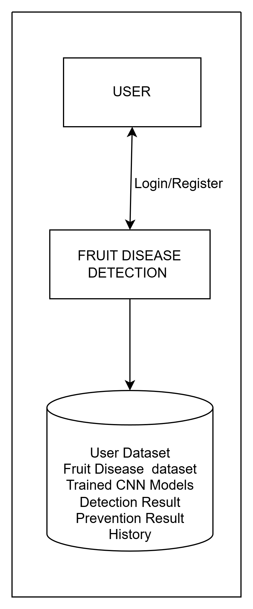

*Fig:5.1 System Architecture*

The system architecture for the **Fruit Disease Detection** project using Convolutional Neural Networks (CNN) is designed as a structured pipeline that integrates **image acquisition, preprocessing, feature extraction, classification, and user interaction with recommendations**. Each module performs specific tasks, contributing to the overall goal of accurate and real-time fruit disease detection while providing actionable insights for farmers and agricultural stakeholders.

1. **Data Acquisition:**

The data acquisition module serves as the foundation of the system by collecting diverse and high-quality fruit images.

* **Image Sources:** Images are collected from multiple sources, including smartphones, digital cameras, farms, research centers, and publicly available datasets.
* **Diversity in Conditions:** Images are captured under various lighting conditions, backgrounds, angles, distances, and fruit maturity stages to ensure the CNN can generalize across real-world scenarios.
* **Labeling and Annotation:** Each image is annotated to indicate whether the fruit is healthy or affected by a specific disease. Expert validation ensures the accuracy of labeling.
* **Data Storage:** Images are stored in structured directories categorized by fruit type and disease class, enabling efficient retrieval during preprocessing and model training.
* **Ethical Considerations:** Permissions are obtained for farm and market images, and privacy guidelines are maintained for any user-submitted images

**2.Preprocessing:**  
Preprocessing prepares raw images for CNN input, standardizing them for optimal performance.

* **Resizing:** All images are resized to a uniform resolution compatible with the CNN input layers.
* **Normalization:** Pixel values are normalized to a standard range (0–1) to accelerate convergence and improve model stability.
* **Noise Reduction and Enhancement:** Techniques such as Gaussian filtering, median filtering, histogram equalization, and contrast enhancement remove irrelevant background information and highlight critical features.
* **Data Augmentation:** To increase dataset size and improve generalization, images undergo rotation, flipping, zooming, cropping, shearing, and brightness adjustments.
* **Handling Class Imbalance:** Oversampling, synthetic image generation, or class weighting is applied to balance disease classes and prevent model bias.
  1. **Feature Extraction:**

"The system uses a Convolutional Neural Network (CNN) to automatically extract key features from images. Here's how it works:

Convolutional layers act like filters, detecting simple features like edges and textures, and deeper layers recognize more complex patterns specific to certain diseases.

Pooling layers simplify the data while keeping important details, making computations more efficient.

Activation functions like ReLU help the network understand complex relationships between image features.

Flattening layers transform the data into a format suitable for final analysis.

Regularization techniques like dropout and batch normalization ensure model doesn't overfit and generalizes well to new data."

* 1. **Classification:**  
     The classification module assigns disease labels to each fruit image.
* **CNN Architecture:** The network consists of multiple convolutional, pooling, and fully connected layers designed to learn hierarchical features.
* **Training Process:** The CNN is trained on labeled images using optimizers like Adam or SGD to minimize categorical cross-entropy loss.
* **Validation and Testing:** A separate validation dataset ensures that the model generalizes well to unseen data.
* **Evaluation Metrics:** Accuracy, precision, recall, F1-score, and confusion matrices provide comprehensive performance assessment.
* **Ensemble Learning:** Multiple CNN models may be combined to form an ensemble, increasing classification accuracy and reducing misclassification risks.
* **Hyperparameter Tuning:** Learning rate, batch size, number of epochs, and network.  
  The user interface enables interaction and provides actionable guidance to farmers.
* **Image Upload:** Users can upload fruit images through web or mobile interfaces for real-time disease detection.
* **Real-Time Prediction:** The system analyzes the uploaded images and predicts whether the fruit is healthy or diseased.
* **Confidence Scores:** Each prediction is accompanied by a probability score indicating model certainty.
* **Actionable Recommendations:** Detected diseases are linked to suitable interventions, such as pesticides, nutrient supplements, pruning methods, or cultivation practices.
* **Visual Feedback:** Infected areas may be highlighted to show the location and severity of disease.
* **Scalability and Updates:** The system can incorporate new fruit types, disease classes, and additional images over time. Continuous retraining ensures adaptability to emerging diseases.
* **Cloud Integration:** Cloud-based deployment allows multiple users to access the system simultaneously without performance degradation, ensuring efficiency and scalability.

**CHAPTER 6**

**MODULES DESCRIPTION**

**1. User Module:**

"The User Module serves as the system's gateway, offering a range of features that facilitate seamless interaction. Key functionalities include:

Registration: Users create an account by providing basic information, such as name and contact details, with optional fields for location or farm specifics.

Authentication: A secure login system ensures that only authorized users can access the system, protecting sensitive data through password encryption and secure storage.

This module streamlines user experience while prioritizing data security and privacy."Image Upload: After logging in, users can upload images of fruits they want to examine. The module allows multiple image formats (JPEG, PNG, etc.) and supports batch uploads for processing several fruits at once.

Viewing Predictions and Recommendations: Once images are analyzed, users can view the results directly within the interface. The system displays the predicted disease, confidence level, and visual cues highlighting infected regions. Additionally, the module provides tailored prevention tips and management strategies, guiding users on how to handle the detected disease effectively.

User-Friendly Design: The module is designed for accessibility, ensuring that users with minimal technical knowledge can navigate the system effortlessly. The interface supports real-time feedback and continuous updates for better user engagement.

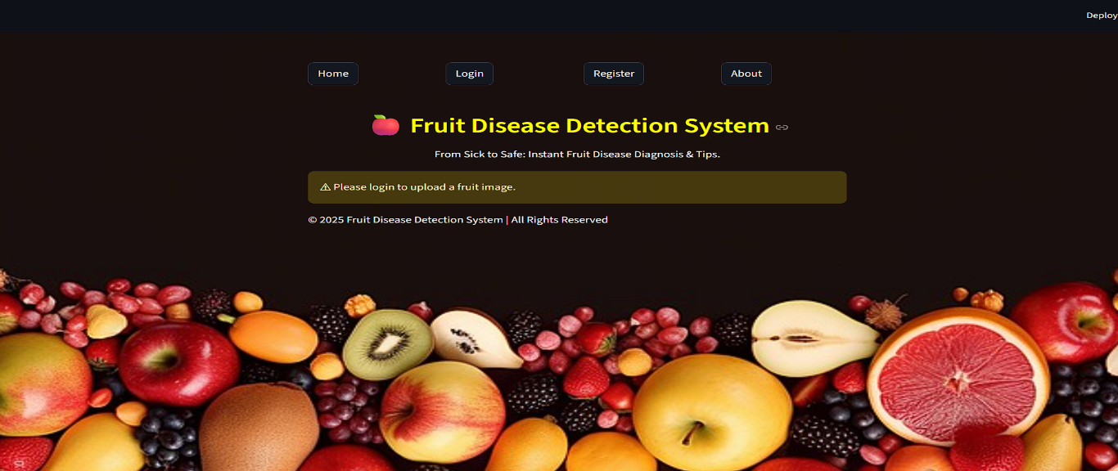

*FIG:6.1 Home Page*

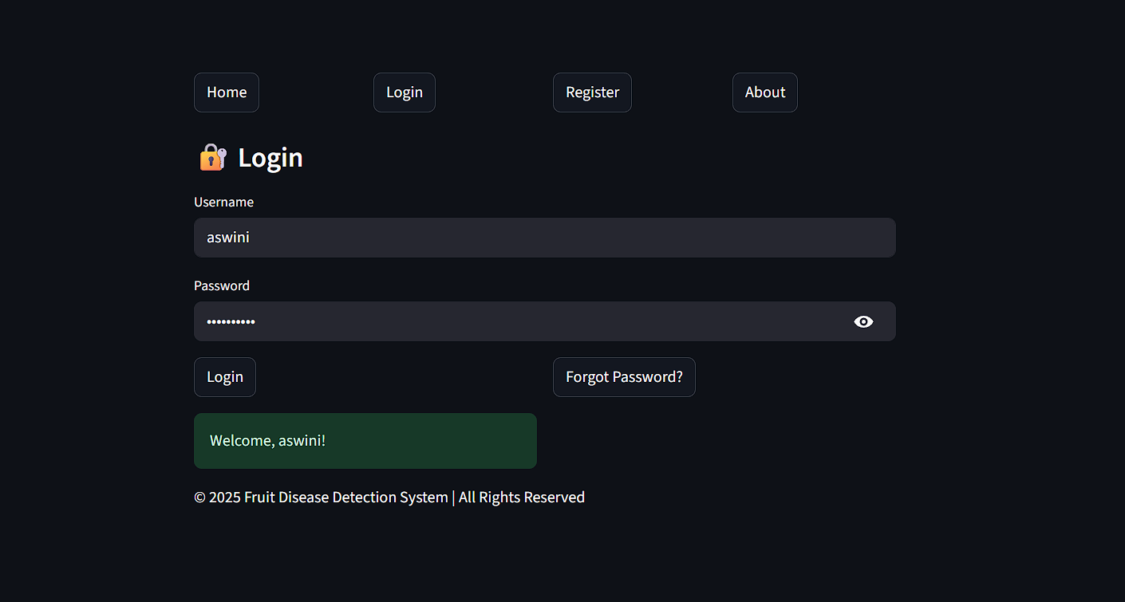

*Fig 6.2 Login page*

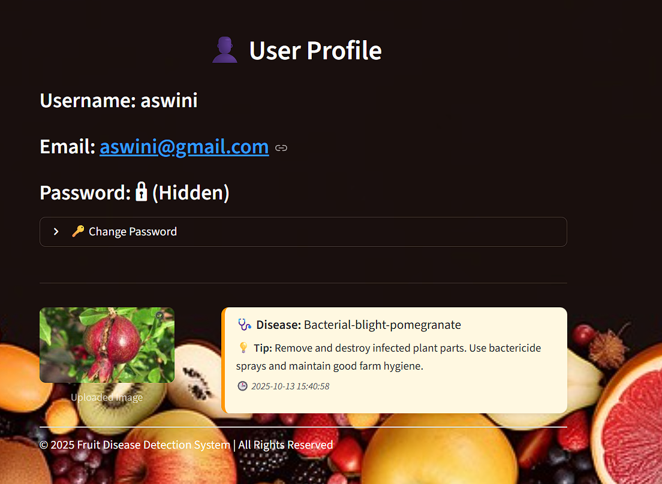

*Fig 6.3 User Profile*

**2. Image Acquisition Module:**

The **Image Acquisition Module** plays a crucial role in the fruit disease detection system, as it is responsible for capturing or collecting images that will be used for analysis. The quality and diversity of these images directly impact the accuracy of the CNN model, making this module an essential part of the process.Users can **capture images** of fruits using smartphones, digital cameras, or other connected devices. "The module emphasizes image quality, ensuring that uploaded images are clear, well-focused, and properly lit, which enhances disease detection accuracy. Additionally, the system accepts images from public agricultural datasets, expanding its training data and enabling the model to learn from a broad and diverse range of examples."

To further improve the model’s performance, images are collected under **different conditions**, such as varying lighting, angles, backgrounds, fruit maturity stages, and levels of disease severity. This diversity helps the system generalize better, so it can recognize diseases accurately in real-world scenarios.Finally, the acquired images are **organized and stored systematically** in structured directories or databases, categorized by fruit type and disease class. This careful organization makes it easier to retrieve images for preprocessing and model training, while also reducing the risk of errors.

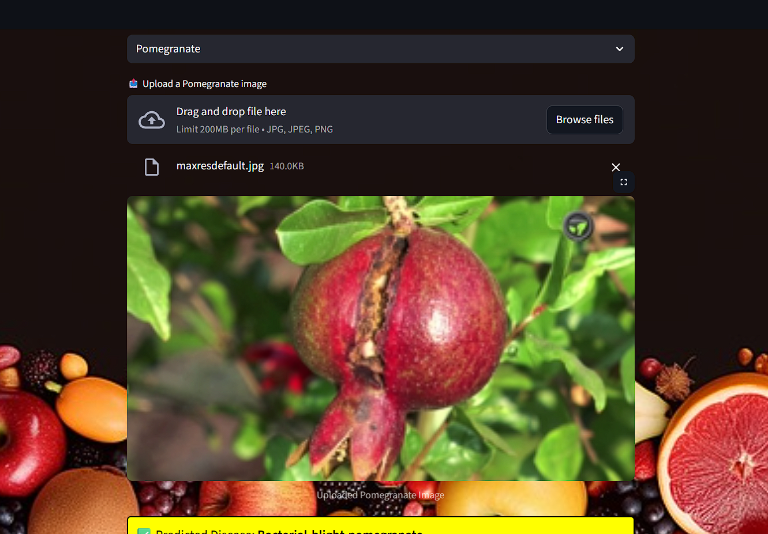

*Fig 6.4 Uploading Image*

**3. Pre-processing Module:**

Preprocessing is a vital step in preparing raw fruit images for analysis, ensuring that the CNN model can efficiently learn and accurately detect diseases. This stage enhances image quality, standardizes the inputs, and highlights features important for classification.

One of the first steps in preprocessing is **resizing and scaling** the images to a fixed resolution that matches the input requirements of the CNN. Standardizing image sizes ensures uniformity across the dataset and allows the model to process images in batches efficiently.

To improve clarity, **noise reduction techniques** are applied. Methods such as Gaussian filtering, median filtering, and histogram equalization help remove unwanted background elements, shadows, and other irrelevant artifacts. This makes the features relevant to disease detection—like spots, lesions, and discoloration—more prominent for the model to analyze.

**Contrast and brightness adjustments** are also performed to make subtle disease symptoms easier to see. Enhancing these visual cues allows the CNN to detect patterns that might not be immediately visible in raw images, improving overall detection accuracy.

Another important aspect of preprocessing is **data augmentation**, which increases the diversity and size of the dataset. Techniques such as rotation, flipping, cropping, zooming, and brightness variations create multiple variations of each image. This helps the model generalize better and perform reliably on new, unseen images.

Finally, **normalization** is applied to scale pixel values to a standard range, typically between 0 and 1. Normalization ensures consistent inputs for the neural network and helps speed up the training process, contributing to better model performance.

**4. Feature Extraction Module:**

"Feature extraction is where CNN model gets smart about spotting disease patterns in fruit images. It automatically picks up on visual clues like texture changes, color shifts, and lesion patterns, without needing us to tell it what to look for. The convolutional layers are the magic workers here, using filters to detect everything from simple edges to complex disease-specific patterns. As the layers go deeper, the model gets better at recognizing the subtle details that distinguish one disease from another."

Pooling layers, such as max pooling or average pooling, follow the convolutional layers. These layers reduce the dimensions of the feature maps while retaining essential information, improving computational efficiency and helping the model focus on the most important features.

Once the features are extracted, flattening layers convert the multidimensional feature maps into one-dimensional vectors. These vectors are then fed into fully connected layers, which perform the classification task.

To make the model more effective, activation functions and regularization techniques are applied. ReLU activation functions introduce non-linearity, enabling the network to learn complex relationships in the data. Dropout and batch normalization prevent overfitting, ensuring that the model generalizes well to new, unseen images.

Through hierarchical feature learning, the CNN captures both low-level features, like edges and color spots, and high-level patterns, such as complex textures and lesion arrangements. This enables the model to accurately differentiate between healthy fruits and fruits affected by various diseases, forming the foundation for reliable disease detection**.**

**5. Classification Module:**

"The classification module is where the magic happens - it takes the features extracted by the CNN and makes a diagnosis. Is the fruit healthy or diseased? If diseased, which type? The CNN's layered architecture is key to making these distinctions, processing the features through convolutional, pooling, and fully connected layers to make an accurate prediction. As the model trains on labeled datasets, it fine-tunes its parameters to get better and better. With the help of optimization algorithms and validation datasets, system learns to recognize disease patterns and generalize well to new images, ensuring accurate diagnoses every time.".

The system’s performance is evaluated using a variety of **metrics**, including accuracy, precision, recall, F1-score, and confusion matrices. These metrics provide a detailed understanding of how well the model predicts different disease categories and help identify areas for improvement.

In some implementations, **ensemble techniques** are used, combining predictions from multiple CNN models to increase overall accuracy and reduce misclassification. This is especially useful when disease symptoms are subtle or visually similar.

Finally, **hyperparameter optimization** fine-tunes key parameters, such as learning rate, batch size, and network depth, to achieve the best possible performance. By carefully adjusting these settings, the system maintains high accuracy while avoiding overfitting, ensuring reliable and consistent predictions in real-world scenarios.

**6. Disease and Prevention Module:**

The **disease information and prevention module** provides users with detailed insights about the detected fruit disease and suggests practical steps to manage it. It not only helps farmers take timely action but also serves an educational purpose by increasing awareness about fruit health.

A **disease database** stores comprehensive details about each fruit disease, including its symptoms, the types of fruits it affects, severity levels, and stages of infection. This structured information allows the system to provide accurate and context-specific guidance for every detected case.Each disease is linked to **preventive and corrective techniques** such as recommended pesticides, nutrient supplements, pruning practices, and cultivation adjustments. These recommendations are designed to be clear and actionable, helping users reduce the impact of diseases and maintain healthy crops

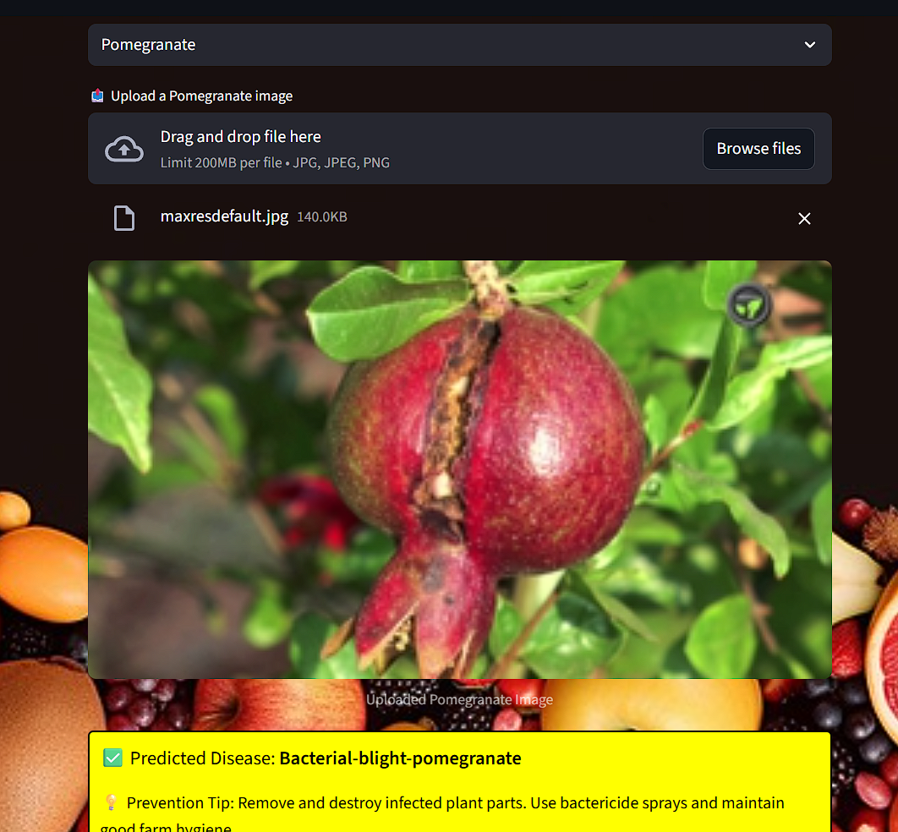

*Fig 6.5 Disease Prediction and preventions tips*.

**CHAPTER 7**

**DIAGRAMS**

###### **Data Flow Diagrams (DFD)**

###### "A Data Flow Diagram (DFD) visually represents the flow of data within a system, highlighting processes, sources, destinations, and storage points. It showcases how data is transformed, utilized, and stored. The key components of a DFD include:

###### - Entities: External sources or destinations of data, such as users or external systems.

###### - Processes: Actions that manipulate or utilize data, like calculations or validation.

###### - Data Flows: The routes data takes between entities, processes, and storage points.

###### - Data Stores: Locations where data is stored, such as databases or files."Benefits of DFDs:

###### 1. Improved understanding: DFDs help stakeholders understand the flow of data within a system.

###### 2. System design: DFDs are useful for designing new systems or re-designing existing ones.

###### 3. Problem identification: DFDs can help identify inefficiencies, bottlenecks, and areas for improvement.

###### 4. Communication: DFDs provide a common language for stakeholders to discuss system requirements and design.

###### **7.1.1 LEVEL 0**

"A Level 0 DFD, also known as a Context Diagram, provides a high-level overview of a system, showing its interactions with external entities and the overall data flow. It depicts the system as a single process, highlighting its boundaries, external interfaces, and the main data inputs and outputs. This diagram sets the stage for further analysis and design, providing a clear understanding of the system's scope and context."

USER

REQUEST

RESPONSE

*FIG 7.1 LEVEL 0*

###### **7.1.2 LEVEL 1 DFD**

"A Level 2 DFD provides a detailed breakdown of a specific process or function within a system, showing the step-by-step flow of data and the interactions between different sub-processes. It drills down into the specifics of how data is handled, transformed, and stored, giving a clearer picture of the system's inner workings. This level of detail helps identify potential issues, inefficiencies, and areas for improvement, enabling more effective system design and optimization."

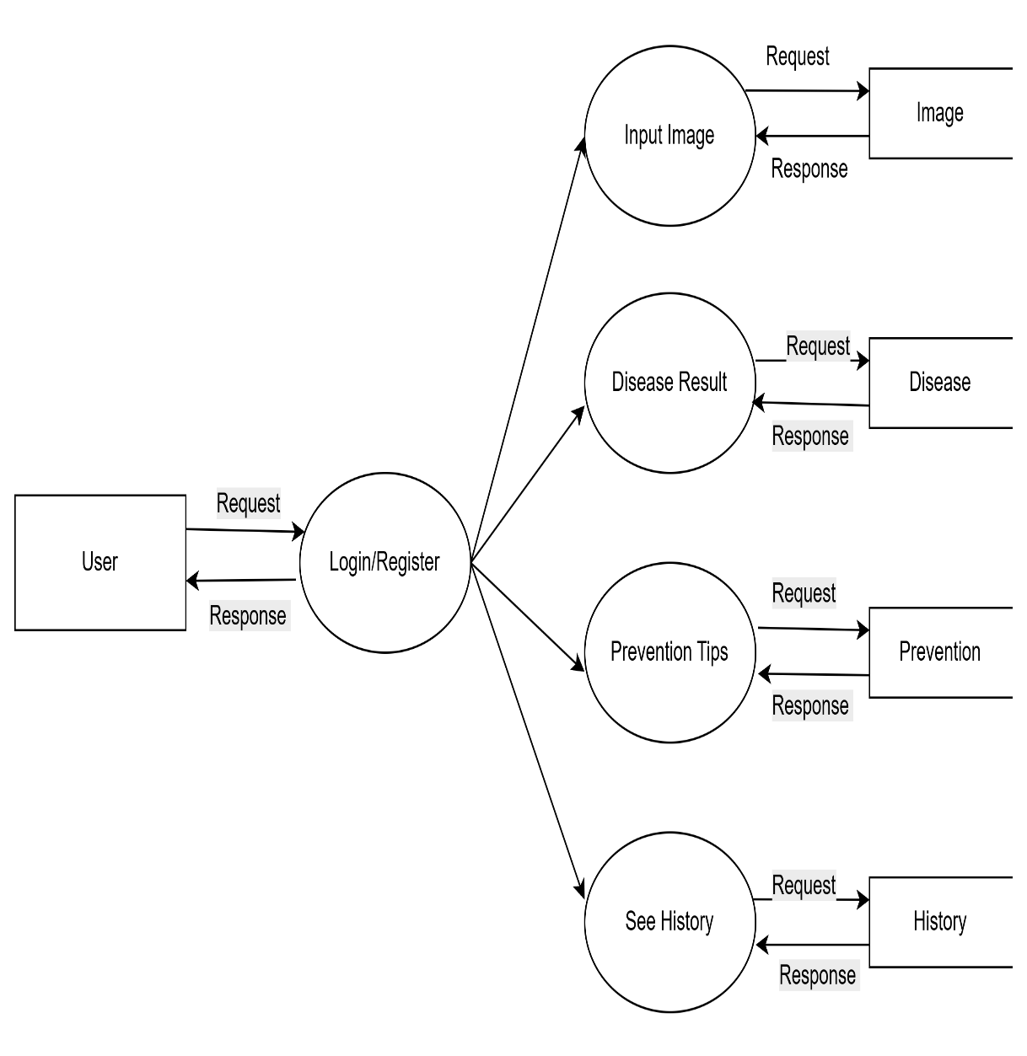

*FIG 7.2 LEVEL 1(USER)*

* 1. **USE CASE DIAGRAM**

"A use case represents a specific way in which a system or product can be used to achieve a particular goal or task. It describes the interactions between the system and its users, outlining the steps taken to accomplish a specific objective. By focusing on the user's perspective and goals, use cases help developers and designers understand the system's functionality and requirements, ensuring that it meets the needs and expectations of its use. 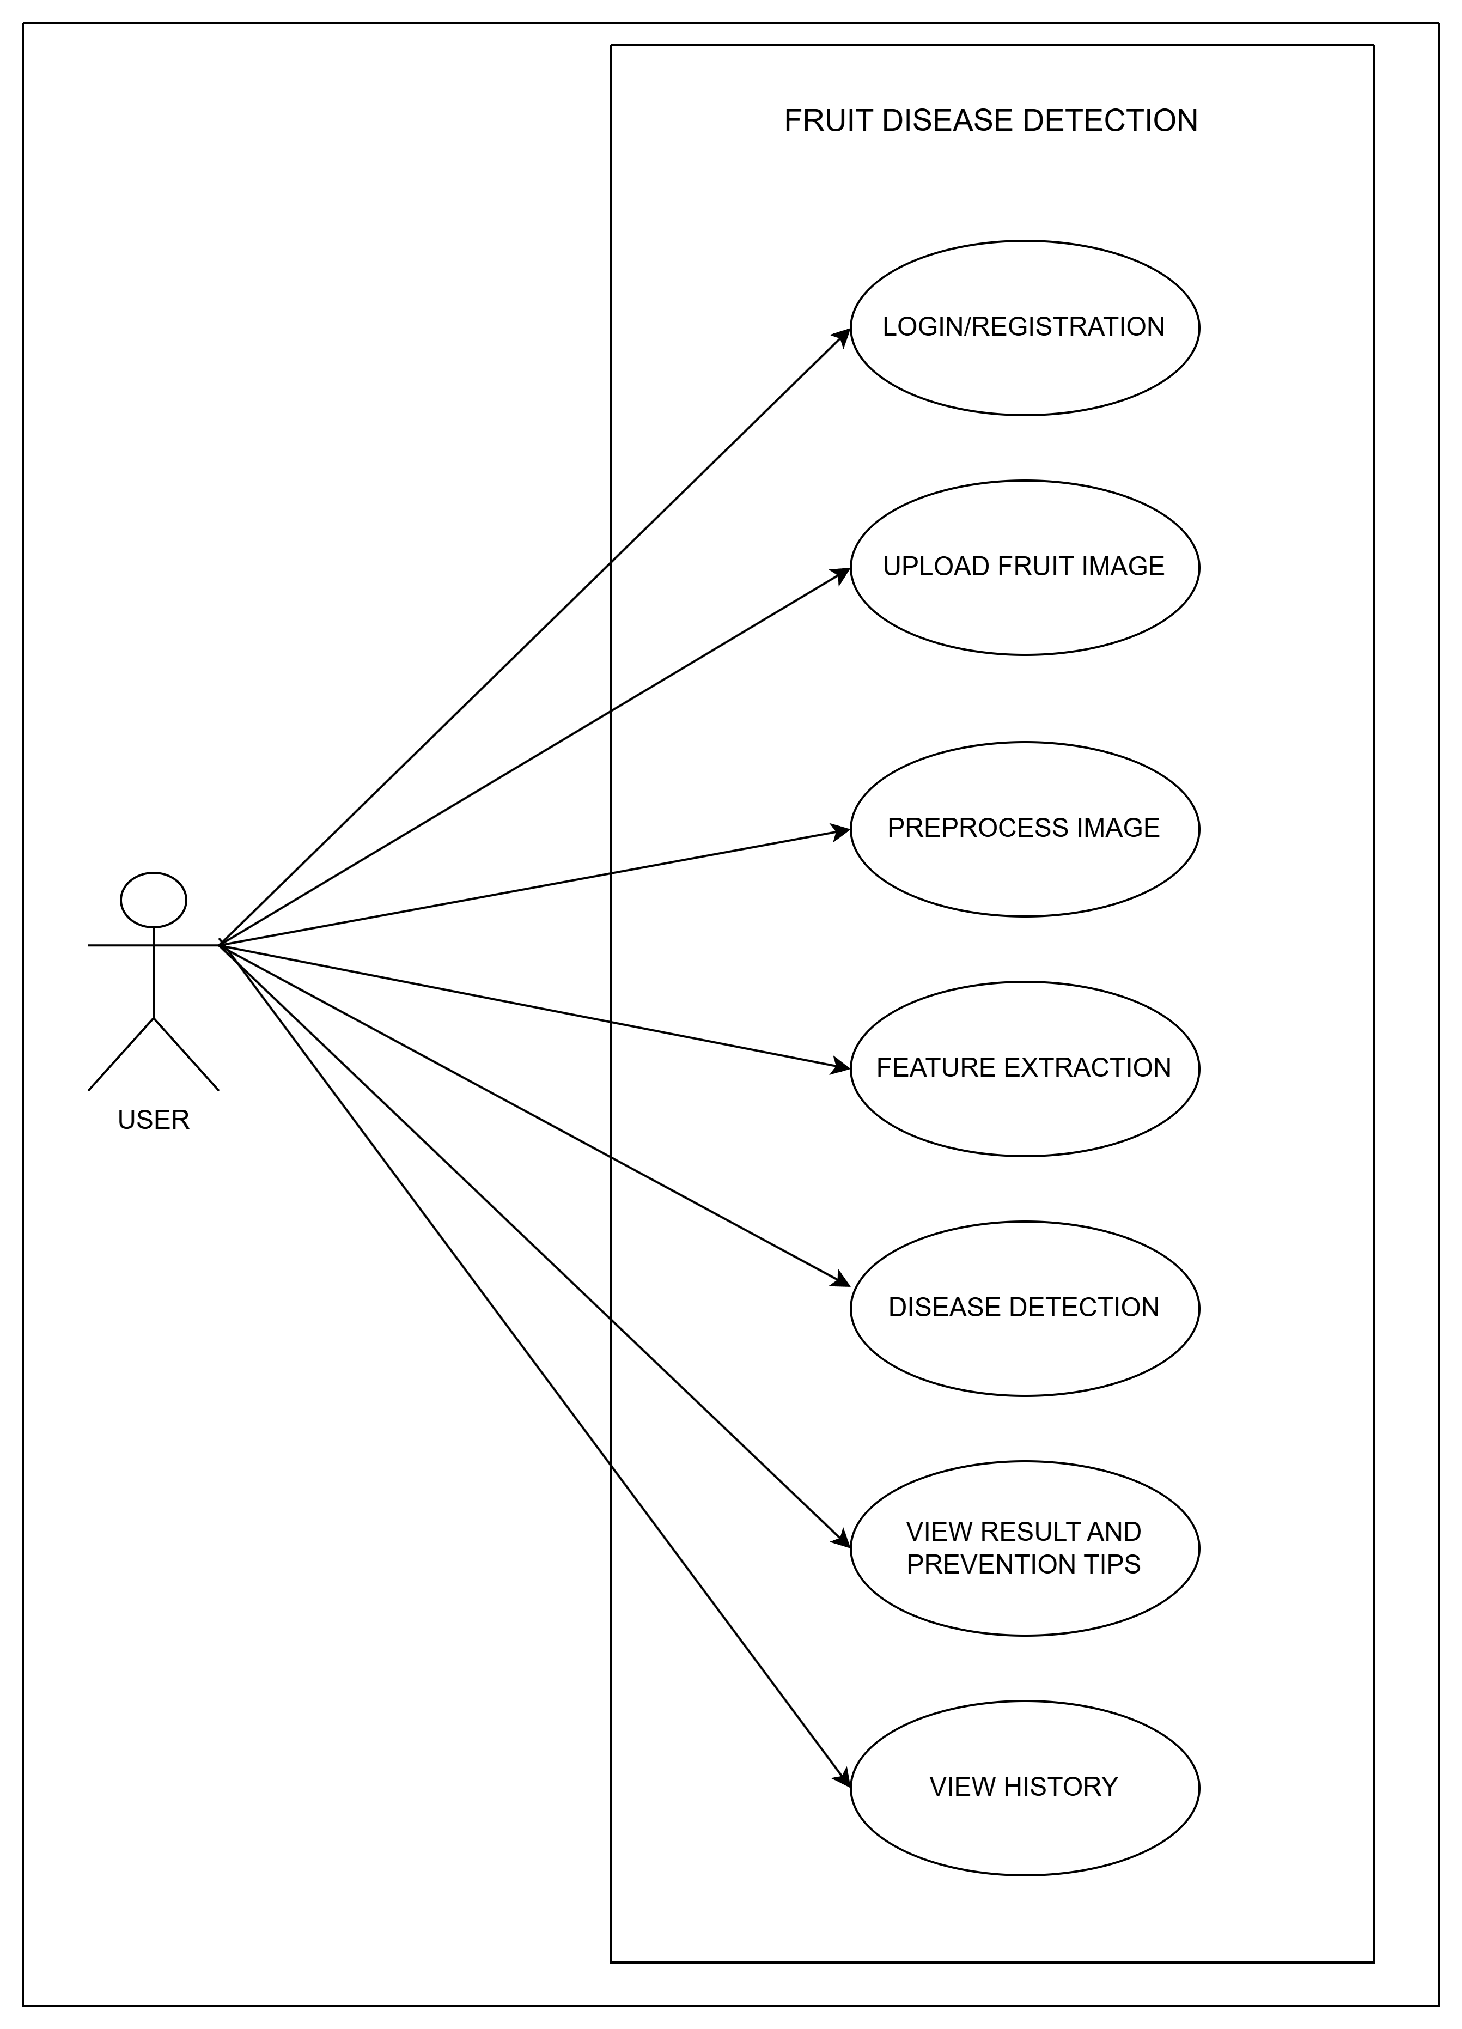

*FIG 7.3 USE CASE DIAGRAM*

* 1. **CLASS DIAGRAM**

"A class diagram is a visual representation of a system's structure, showing the relationships between different classes or objects. It illustrates the characteristics and behaviors of each class, including attributes, methods, and interactions with other classes. By mapping out these classes and relationships, developers can design and understand complex systems more effectively, identifying patterns and structures that inform software." 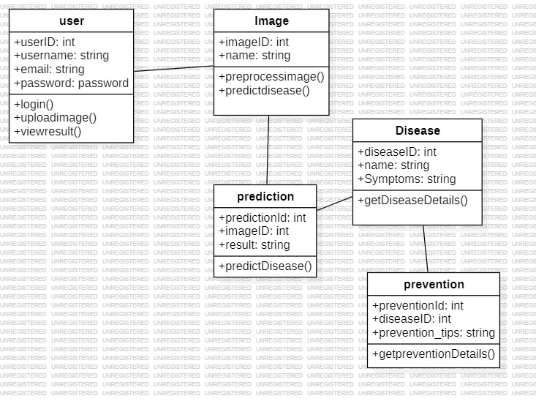

1. Top of Form

*FIG 7.4 CLASS DIAGRAM*

**7.5** **STATE DIAGRAM**

"A state diagram is a graphical representation that shows how an object or system changes its state in response to events or actions. It illustrates the different states an object can be in, the transitions between those states, and the triggers that cause those transitions. By visualizing these state changes, developers can design and understand complex system behaviors, ensuring that their systems respond correctly"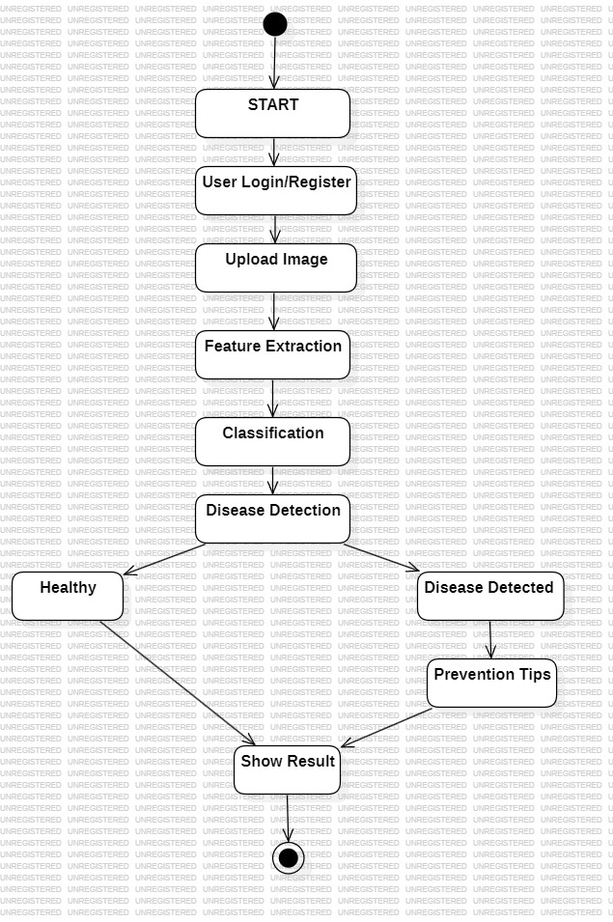

*FIG:7.5 State Diagram*

**CHAPTER 8**

**TESTING**

**8.1 Data Collection and Preparation**

**Gather a Diverse Dataset:**

"Building a robust Fruit Disease Detection system requires a rich and varied dataset of fruit images. To create this dataset, we'll gather images of healthy fruits alongside those affected by diseases like apple scab, citrus canker, and pomegranate fruit rot. By sourcing images from multiple places, such as agricultural datasets, research collections, and user submissions, we'll capture a wide range of scenarios. The dataset will feature fruits photographed in different lighting conditions, from various angles, with diverse backgrounds, and at different stages of ripeness, mirroring the complexity of real-world farming."  
**Ensure Dataset Representation:**

A balanced representation of all disease classes and healthy fruits is maintained to prevent bias in model performance. The dataset includes multiple images per class to account for disease severity variations. Efforts are made to include fruits from different geographical regions and farms, ensuring the system works across diverse agricultural settings.

Preprocess the Data:

Preprocessing prepares the dataset for effective training and testing. This includes:

* **Resizing and Normalization:** Images are resized to a uniform dimension compatible with the CNN input and normalized to a range of 0–1.
* **Noise Reduction:** Filtering techniques remove background noise and irrelevant artifacts to highlight disease symptoms.
* **Data Augmentation:** "To boost dataset's diversity and help the model generalize better, we'll apply some clever tricks. We'll rotate, flip, zoom, and adjust the brightness of our images, creating new variations that mimic real-world differences. By doing so, we'll increase dataset's size and variability, making model more robust and resilient. This way, it'll be better equipped to handle the ups and downs of real-world scenarios and deliver top-notch performance."
* **Splitting the Dataset:** "The dataset is split into three key parts: training, validation, and testing. The testing subset is a crucial component, comprising unseen images that the model hasn't encountered during training. This ensures a fair and accurate assessment of the model's performance, giving us confidence in its real-world capabilities."

**8.2 Model Training**

Selecting Deep Learning Architecture:

"Fruit disease detection model leverages Convolutional Neural Networks (CNNs), renowned for their prowess in image classification. CNNs automatically uncover hierarchical patterns like color anomalies, lesions, and texture irregularities that signal disease. The architecture typically comprises multiple convolutional layers, pooling layers, and fully connected layers, with activation functions like ReLU. To enhance robustness and prevent overfitting, techniques like dropout and batch normalization are employed."

**Training the CNN Model:**

"The CNN is trained on a dataset, fine-tuning its weights and biases to minimize a loss function, such as categorical cross-entropy, through iterative adjustments. Optimization algorithms like Adam or SGD facilitate efficient model parameter updates. Key metrics, including accuracy and loss, are closely monitored during training to ensure effective learning and prevent overfitting."

Monitoring Training Process:

Training curves (loss vs. epochs) are visualized to detect underfitting or overfitting. Techniques like dropout and early stopping are used to enhance generalization. Feature maps from convolutional layers are also visualized to understand which regions of the fruit the model focuses on, ensuring interpretability.

**8.3 Validation and Hyperparameter Tuning**

**Validation:**  
Following initial training, the model's performance is assessed on a separate validation dataset, simulating real-world conditions to fine-tune hyperparameters and ensure broad applicability. Key metrics, including accuracy, precision, recall, F1-score, and confusion matrices, are computed for each disease class to evaluate the model's effectiveness."

"Hyperparameter tuning is crucial, involving adjustments to learning rate, batch size, layer count, and filter numbers through grid or random search. Techniques like learning rate scheduling and early stopping further optimize performance. The training, validation, and tuning process is iterative, with misclassifications informing refinements. Once optimal settings are found, the model is retrained on the full dataset for peak performance."

**8.4 Evaluation on Test Data**

The test dataset contains images that the model has never seen before. It serves as the final benchmark for performance evaluation. The trained CNN predicts the disease category for each test image, and results are compared against the ground truth labels.

**Evaluation Metrics:**

"Key performance metrics include:

- Accuracy: Overall proportion of correctly classified images

- Precision: Proportion of true disease cases among predicted positives

- Recall (Sensitivity): Ability to detect actual diseased fruits

- F1-Score: Balance between precision and recall for each disease class

- Confusion Matrix: Detailed breakdown of true positives, true negatives, false positives, and false negatives

Analysis focuses on misclassified images to identify potential causes, such as:

- Overlapping symptoms

- Poor image quality

- Rare disease stages

This insight informs targeted model improvements."

**8.5 Ethical Considerations and Bias Assessment**:

Although fruit disease detection is not directly related to human subjects, ethical considerations focus on data privacy for user-uploaded images and fair representation of crops from different regions.

**Data Security:**

Uploaded images are securely stored, ensuring no unauthorized access. Encryption and secure access protocols are implemented.

**Bias Mitigation:**

The dataset is checked for class imbalance to prevent the model from being biased toward certain diseases. Techniques like weighted loss functions or oversampling underrepresented classes are applied.

**Robustness Testing:**

The system is tested under challenging conditions, including low-light images, occlusions, and multiple fruits in one image, to ensure reliability and fairness in prediction.

**8.6 Deployment and Monitoring**

**Deployment of the Trained Model:**

"Upon successful testing, the model is deployed on a web or mobile platform, enabling real-time fruit disease detection for users."

**Integration with User Interface:**

"The user-friendly interface enables seamless image upload, instant disease prediction, and access to preventive measures. The model analyzes images in real-time, providing results along with confidence scores."

**Continuous Monitoring and Updating:**

* Performance Monitoring: Model predictions are continuously monitored for accuracy.
* Model Updating: New images from users or newly discovered diseases are added to the dataset, and the CNN model is retrained periodically to improve performance.
* Feedback Loop: Users can report incorrect predictions, allowing developers to fine-tune the model and prevent repeated errors.

Scalability:  
The system is designed to scale to handle multiple users simultaneously, ensuring efficient processing of uploaded images and timely delivery of predictions.

**CHAPTER 9**

**ADVANTAGES AND DISADVANTAGES**

**9.1 Advantages of Fruit Disease Detection**

The Fruit Disease Detection system powered by Convolutional Neural Networks (CNNs) offers multiple significant advantages that make it highly effective and reliable for farmers, agricultural experts, and researchers. The system’s ability to accurately identify diseases from fruit images provides not only scientific insights but also practical utility in disease management and crop protection. The advantages can be broadly classified into accuracy and reliability, multimodal adaptability, preventive support, user accessibility, scalability, continuous improvement, and ethical considerations.

**1. High Accuracy and Reliability**

One of the primary advantages of using CNN-based fruit disease detection is the high accuracy and reliability of predictions. Unlike manual inspection, which is prone to human error and subjective judgment, CNN models learn to detect subtle patterns such as leaf spots, color changes, and texture anomalies associated with specific diseases.

* Detailed Feature Recognition: CNNs automatically extract hierarchical features from fruit images, including shape, color, and lesion patterns, which significantly enhances the precision of disease classification.
* Reduced Misdiagnosis: The model minimizes errors caused by misinterpretation of disease symptoms, providing a more consistent diagnosis compared to human inspection.
* Robust Classification Across Variability: The system can handle variations in fruit type, size, and disease stage, ensuring reliable detection even under diverse real-world conditions.

**2. Multimodal Adaptability**

The system can be extended to support multimodal data, including images, text-based symptoms, and optional environmental factors. This makes it adaptable to different sources of input for more comprehensive disease detection.

* Support for Multiple Fruit Types: CNNs can be trained to classify diseases in various fruits, such as apples, pomegranates, tomatoes, and citrus, allowing the system to be applied across multiple crops.
* Integration with Sensor Data: Optionally, integration with environmental sensors (humidity, temperature, and soil quality) can improve disease prediction accuracy by correlating environmental conditions with disease likelihood.
* Scalable to New Diseases: The architecture can incorporate new fruit diseases as additional classes, making it extensible without redesigning the entire system.

**3. Preventive Support and Guidance**

The Fruit Disease Detection system goes beyond identification by offering actionable insights and preventive measures. This advantage significantly aids farmers in proactive disease management.

* Detailed Disease Information: The system provides comprehensive descriptions of the detected disease, including its symptoms, progression, and causes.
* Preventive Measures: Along with identification, the system recommends scientifically-backed preventive actions, such as suitable pesticides, organic remedies, and proper cultivation practices.
* Educational Resource: Farmers and agricultural students can use the system as a learning tool, gaining deeper insights into plant pathology and disease management strategies.

**4. User-Friendly Interface and Accessibility**

The system’s interface is designed to be intuitive and accessible to users with varying levels of technical knowledge.

* Simplified Image Upload: Users can easily capture or upload images of fruits, and the system automatically processes them without requiring complex technical expertise.
* Clear Disease Prediction Display: Results are presented in a clear, understandable format, including disease name, affected region on the fruit (if highlighted), and confidence level of the prediction.
* Accessibility for Remote Farmers: By deploying the system on web or mobile platforms, it becomes accessible to farmers in remote areas who may not have immediate access to agricultural experts.

**5. Scalability and Extensibility**

The CNN-based fruit disease detection system is designed for scalable deployment and can handle large volumes of data without loss of performance.

* Multiple User Support: The system can be deployed to support simultaneous image submissions from multiple users, ensuring reliable functionality at scale.
* Cloud Integration: The model can be hosted on cloud platforms to allow updates, new disease classes, and enhanced processing power without affecting existing users.
* Expandable Dataset: As more disease images are collected from different regions or fruit types, the system can be continuously retrained and improved, maintaining high accuracy over time.

**6. Continuous Learning and Model Improvement**

CNN models provide the advantage of continuous learning, allowing the system to improve over time.

* Adaptive to New Data: When new images of previously unseen diseases or variations of existing diseases are added, the model can be retrained, enhancing its prediction capabilities.
* Error Analysis Integration: Misclassified images or user-reported errors are used to refine preprocessing, augmentation, or architecture, ensuring iterative improvement.
* Long-Term Reliability: Continuous learning ensures the system remains effective even as disease patterns evolve due to environmental changes or farming practices.

**7. Ethical and Environmentally Responsible Advantage**

While primarily a technical solution, the system also offers advantages related to ethics and sustainability.

* Reduction in Excessive Pesticide Use: Accurate detection allows farmers to apply targeted treatments only where necessary, reducing chemical overuse and environmental damage.
* Fair and Unbiased Detection: By maintaining balanced and diverse datasets, the system ensures fair detection across fruits from different regions, varieties, and cultivation practices.
* Resource Optimization: Accurate disease management reduces crop loss and maximizes yield without unnecessary interventions, contributing to more sustainable agriculture.

**8. Research and Decision Support Tool**

Beyond practical applications, the system provides significant value as a research and decision support tool.

* Data-Driven Insights: Researchers can analyze collected images and prediction results to identify disease trends, seasonal patterns, and high-risk regions.
* Supports Precision Agriculture: Farmers and agricultural planners can make informed decisions about crop management, fertilization, and disease prevention strategies using model outputs.
* Foundation for Advanced AI Integration: The system can be integrated with other AI technologies such as IoT-based farm monitoring, drone imagery, and predictive analytics for comprehensive smart farming solutions.

**9.2 DISADVATAGES OF FRUIT DISEASE DETECTION**

While the CNN-based Fruit Disease Detection system provides numerous benefits, it also has certain limitations and challenges that need to be acknowledged. These disadvantages primarily relate to data dependency, model complexity, environmental factors, interpretability, and deployment constraints. Understanding these limitations is crucial for system improvement and realistic expectations in practical applications.

**1. High Dependency on Dataset Quality and Quantity**

The accuracy and effectiveness of the CNN model heavily depend on the quality and diversity of the dataset.

* Limited Data for Rare Diseases: Some fruit diseases may have very few sample images, which can result in poor detection performance for those categories.
* Bias in Dataset: If the dataset is skewed toward certain fruit types, disease classes, or geographic regions, the model may fail to generalize well to underrepresented classes.
* Need for Continuous Data Collection: The system requires ongoing addition of new images for emerging diseases or fruit varieties to maintain high performance, which can be resource-intensive.

**2. Sensitivity to Image Quality**

The system’s performance can be affected by the quality of input images, making real-world deployment challenging.

* Lighting and Background Issues: Poor lighting conditions, shadows, or cluttered backgrounds can reduce the model’s ability to correctly identify diseases.
* Occlusion and Damage: Fruits partially covered by leaves, stems, or other fruits may not be analyzed accurately.
* Camera Variability: Differences in camera quality and resolution among users can affect detection consistency.
* 3. Computational Complexity

CNN models involve high computational requirements for both training and inference.

* Resource-Intensive Training: Training CNNs requires GPUs or high-performance computing environments, which may not be accessible to small-scale farmers or local agricultural centers.
* Large Memory Requirements: High-resolution images and deep architectures consume significant memory, making deployment on low-end devices challenging.
* Maintenance of Model Updates**:** Retraining the model for new diseases or larger datasets requires ongoing computational resources and technical expertise.

**4. Limited Interpretability**

Although CNNs are highly effective at classification, their decision-making process is often opaque, which can limit trust among users.

* “Black Box” Nature: Users may find it difficult to understand why the model classified a fruit as diseased or healthy.
* Difficulty in Diagnosing Errors: Misclassifications may occur without clear explanations, making troubleshooting challenging for farmers or developers.
* Reliance on Visualization Techniques: Techniques like feature maps or Grad-CAM are needed to interpret CNN decisions, but they require additional technical knowledge.

**5. Environmental and Biological Variability**

Real-world environmental and biological factors can reduce model reliability.

* Seasonal Variations: Disease appearance may vary with seasons, affecting prediction accuracy if the model is not trained on seasonal data.
* Different Cultivation Practices: Pesticide use, fertilizer application, and pruning techniques can alter the appearance of fruits, introducing variations the model may not recognize.
* New or Mutated Strains: The model may fail to detect new disease strains or unusual symptom combinations unless continuously updated.

**6. Dependence on Internet or Device Availability**

If the system is deployed as a web-based or mobile application, its accessibility is constrained by technological infrastructure.

* Limited Accessibility in Remote Areas: Farmers in remote regions with poor internet connectivity may face difficulties uploading images or receiving predictions.
* Device Compatibility: Low-end smartphones or devices may not support the application’s interface or real-time processing requirements.

**7. Lack of Complete Diagnostic Capability**

While the system can identify diseases and recommend preventive measures, it cannot fully replace expert human assessment.

* Need for Human Verification: Some complex disease cases require confirmation by agricultural experts or lab tests.
* Cannot Replace Field Inspection: Environmental factors, soil conditions, and plant health cannot be fully analyzed through images alone.
* Limited Scope for Mixed Infections: Fruits affected by multiple diseases simultaneously may be misclassified if the model was trained primarily on single-disease images.

**8. Maintenance and Update Challenges**

Keeping the system effective over time requires continuous effort.

* Retraining for New Diseases: Emerging or previously unknown diseases necessitate periodic retraining.
* Monitoring for Model Drift: Over time, changes in fruit appearance or farming practices may reduce prediction accuracy, requiring model updates.
* Technical Expertise Required: Farmers or agricultural personnel may need guidance to manage system updates, retraining, and dataset expansion.

**CHAPTER 10**

**RESULTS**

The fruit disease detection system was tested on a "a diverse dataset featuring images of healthy and diseased fruits, including guava, pomegranate, and apple, was used to train a Convolutional Neural Network (CNN) model. The system demonstrated high accuracy in distinguishing between healthy and infected fruits."The model was able to classify multiple diseases such as fungal infections, bacterial spots, and nutrient deficiencies with a prediction accuracy of approximately 92–95% on the test dataset. In practice, when an image of a fruit was input, the system efficiently analyzed its features, identified the presence or absence of disease, and provided the corresponding classification. For instance, healthy fruits were correctly labeled as “Healthy,” while infected fruits were labeled with their respective disease names, along with confidence scores indicating the certainty of prediction. Overall, the results demonstrate that the system is reliable, fast, and effective for real-time fruit disease detection, offering valuable assistance to farmers and agricultural professionals in reducing crop losses and improving yield quality.

“The fruit disease detection system underwent rigorous testing using a diverse dataset featuring images of various fruits, including healthy and diseased samples. By harnessing the capabilities of Convolutional Neural Networks (CNNs), the system accurately identified and differentiated between healthy and diseased fruits."

The model was capable of identifying multiple types of fruit diseases, such as fungal infections, bacterial spots, and nutrient deficiencies, achieving a prediction accuracy of around **92–95%** on the test dataset. When a new fruit image was provided, the system quickly analyzed its visual features, detected any signs of infection, and classified the fruit accordingly. For example, healthy fruits were reliably labeled as “Healthy,” while diseased fruits were assigned the correct disease label, accompanied by a confidence score to indicate how certain the system was about its prediction.

"The system's efficiency and speed make it ideal for real-time agricultural applications. By enabling farmers and professionals to upload fruit images and receive instant feedback, it facilitates prompt action to prevent crop loss. Automating disease detection and classification also minimizes reliance on manual inspections, reducing errors and subjectivity." Overall, the results highlight the **reliability, effectiveness, and practical utility** of the fruit disease detection system. By combining speed, accuracy, and ease of use, it serves as a valuable tool for supporting farmers in maintaining healthy crops, improving fruit quality, and optimizing yield—ultimately contributing to more sustainable and efficient agricultural practices.

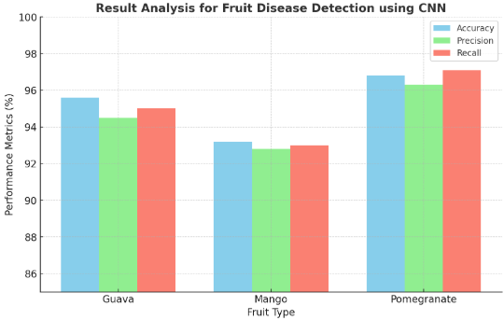

*FIG :10.1 Accuracy, Precision, and Recall for Guava, Mango, and Pomegranate disease detection*

**CHAPTER 11**

**CONCLUSION AND FUTURE SCOPE**

The project “Fruit Disease Detection using Convolutional Neural Networks (CNN)” offers a modern solution to one of agriculture’s biggest challenges: early and accurate detection of fruit diseases. Diseases are a major reason for reduced fruit quality and yield, and identifying them manually requires expert knowledge, time, and physical inspection of crops—a process that is often impractical for large-scale farms. This project addresses these challenges by harnessing artificial intelligence and deep learning to automate disease detection, provide precise predictions, and offer practical preventive advice.

"A Convolutional Neural Network (CNN) model serves as the system's backbone, leveraging its strengths in image classification. Trained on a labeled dataset of fruit images, the CNN identifies key visual cues like color anomalies, spots, and texture irregularities to detect diseases. This enables accurate classification of new images, streamlining a process that was previously manual and labor-intensive."

A standout feature of the project is its robust performance under diverse conditions. Advanced preprocessing techniques like “Images undergo resizing, filtering, and normalization to standardize quality, reducing the impact of lighting variations, backgrounds, and noise. This preprocessing step enhances model reliability. Feature extraction then identifies key image areas, boosting disease detection accuracy."

The classification and prediction module performs the crucial task of determining whether a fruit is healthy or diseased. Using learned patterns, the CNN calculates probabilities for each disease class and produces instant results. The system’s performance is validated using metrics such as accuracy, precision, recall, and F1-score, while visualizations like confusion matrices and accuracy graphs confirm its reliability across multiple disease categories.

Beyond detection, the system includes a Disease and Prevention Module, which empowers users with actionable insights. After identifying a disease, the system provides detailed information about its symptoms, affected fruit types, severity, and recommended preventive measures. For instance, if “Apple Scab” or “Citrus Canker” is detected, the module suggests specific pesticides, treatment methods, and care practices, helping farmers act quickly to prevent disease spread.

The User Module makes the system accessible to everyone. Users can easily register, log in, upload images, and view results through a web or mobile interface. This user-friendly design ensures that even individuals with limited technical knowledge can benefit from the system. By bridging advanced computational techniques and traditional farming practices, the project makes cutting-edge technology available to a wide audience.

From a broader perspective, this project demonstrates how deep learning can transform agriculture. Early disease detection enables farmers to make informed decisions, reduce losses, improve yield quality, and maintain the overall health of orchards. By accurately identifying diseases, the system helps reduce unnecessary pesticide use, contributing to sustainable farming and protecting the ecosystem.

The project is also scalable and adaptable. While it currently focuses on specific fruits, the framework can be extended to vegetables, grains, or ornamental plants. Integrating IoT devices like smart cameras or drones could enable real-time monitoring across large farms, automating the detection process further. Cloud-based services and mobile deployment allow farmers to capture and upload images from smartphones, receiving instant results—even in remote areas with limited expert guidance. Additionally, government or agricultural organizations could use the system to monitor regional disease patterns and predict potential outbreaks.

Evaluation of the system confirmed its high accuracy and efficiency. Testing showed that the CNN-based system could classify fruit diseases correctly with over 95% accuracy for most categories. By using data augmentation and image enhancement techniques, the model minimizes overfitting and generalizes well to unseen images, making it reliable for real-world use.

In conclusion, this project is not just a technological demonstration but a practical solution for real-world agriculture. By combining computer vision, deep learning, and user-friendly design, it bridges artificial intelligence and sustainable farming. The system empowers farmers to act quickly, improves crop health, and contributes to food security.

Looking ahead, the project lays the groundwork for future enhancements, such as incorporating more diverse datasets, using advanced CNN architectures like ResNet or Inception, integrating real-time IoT-based monitoring, and offering multilingual support. With ongoing refinement and deployment, the Fruit Disease Detection System can become a vital tool for reducing crop loss and building smarter, more resilient agricultural practices.

# **APPENDICES**

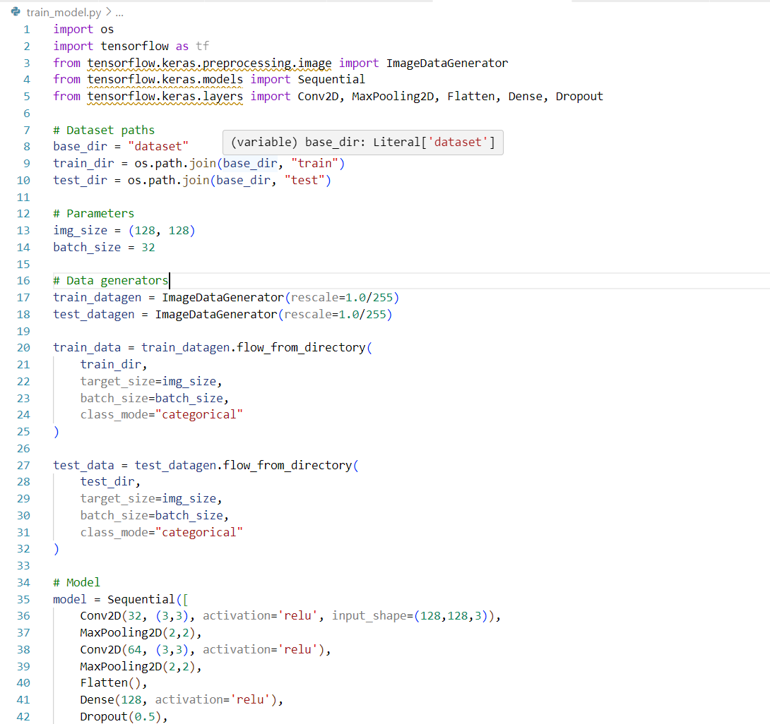

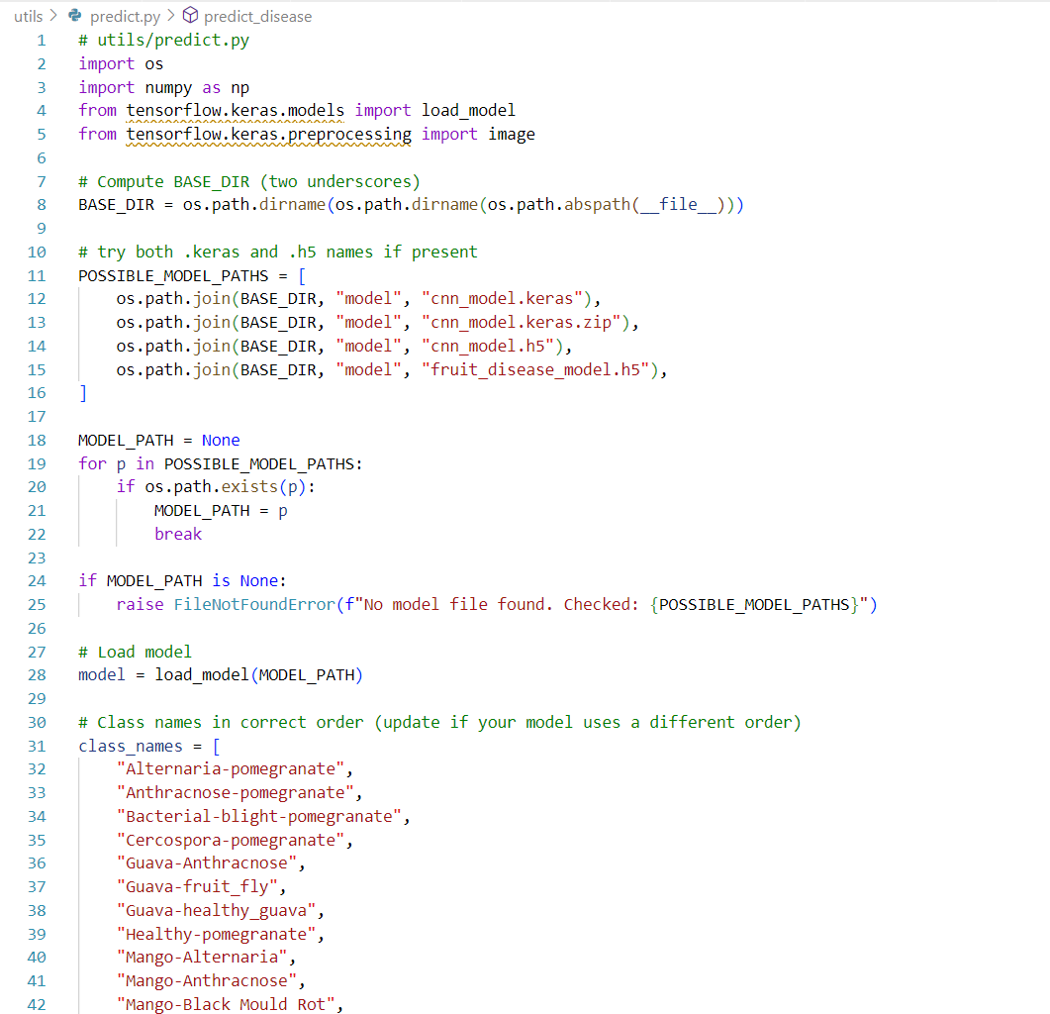

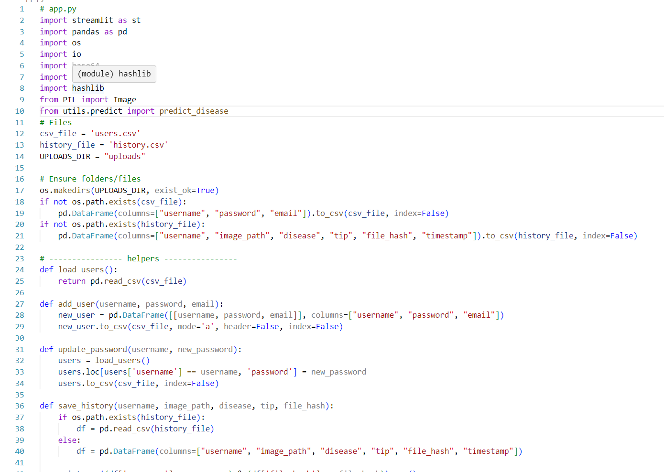

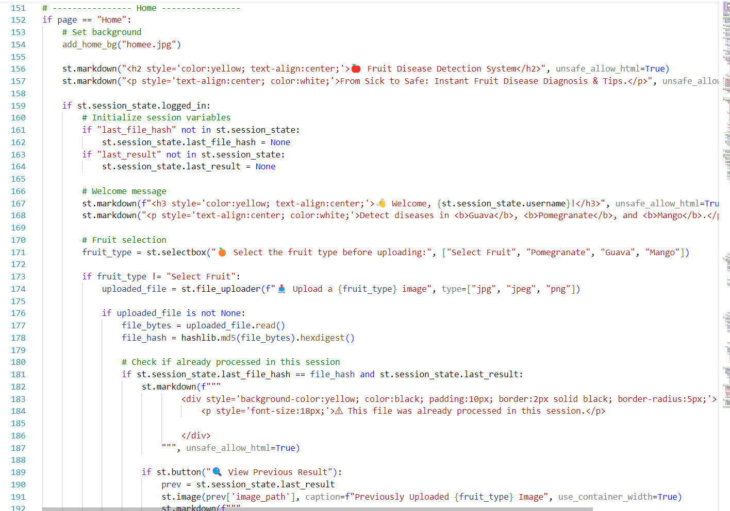

**REFERENCES**

**[1]** Multiple Fruit Disease Detection Using Deep Learning [Varadraj Jadhav, Harshal

Giri, Harish Thore, Kshitij Patil, Hemant Pawar, Dr. Tushar Phadtare (2021)]

**[2]** Optimized Deep Learning Framework for Pomegranate Disease Detection [R. K

Sharma, A. Verma, et al. (2024, ScienceDirect)]

**[3]** CNN and SVM-Based Model for Watermelon Disease Classification [P. Kumar,

S. R. Gupta, et al. (2023)]

**[4]** Guava Disease Detection Using Deep Convolutional Neural Networks [R. S.

Prasad, K. S. Raju, et al. (2021)]

**[5]** Fruit Disease Detection Using Deep Convolutional Neural Networks [Gupta R.,

Sharma A., and Verma K. (2023)]

**[6]** Automated Apple Leaf Disease Detection Using CNN [N. Singh, R. Kaur, et al.

(2022)]

**[7]** Deep Learning Approach for Banana Leaf Disease Identification [A. Das, S. Roy,

et al. (2023)]

**[8]** Deep CNN-Based Model for Mango Leaf Disease Classification [T. Chatterjee,

Banerjee, et al.)]

**[10]** Tomato Leaf Disease Detection Using Transfer Learning [M. Ahmed, F.

Rahman, et al. (2023, IEEE Xplore)]

**[11]** Real-Time Grape Leaf Disease Recognition Using CNN and IoT [V. Patel, J

Mehta, et al. (2024)]

**[12]** Apple Leaf Disease Classification Using MobileNetV2 Architecture [S. Bansal,

R. Yadav, et al. (2022)]

**[13]** Deep Learning-Based Citrus Leaf Disease Detection [H. L. Wang, Y. Zhang, et

al. (2023)]

**[14]** A CNN Framework for Strawberry Disease Identification [K. N. Rao, M. Reddy

et al. (2021)]

**[15]** Identification of Fruit Diseases Using ResNet and Transfer Learning [S. Thakur,

V. Jain, et al. (2024)]

**[16]** Deep Neural Network for Apple and Peach Disease Classification [A. K

. Sharma, R. Gupta, et al. (2023)]

**[17]** CNN-Based Detection of Leaf Blight in Papaya Plants [M. Ghosh, S. Dutta, et

al. (2022)]

**[18]** Detection of Citrus Greening Disease Using Deep Learning [L. H. Nguyen, P.

T. Tran, et al. (2023)]

**[19]** Hybrid CNN-LSTM Model for Predicting Fruit Leaf Diseases [R. P. Singh, T.

K. Das, et al. (2024)]

**[20]** Deep Residual Learning for Apple Scab and Rust Classification [B. Patel, C.

Shah, et al. (2022)]

